Califia Perfusion Simulator
Getting Started with Califia Perfusion Simulator


January 2023

Important Information

No part of this work may be reproduced in any form or by any means - graphic, electronic, or mechanical, including photocopying, recording, taping, or information storage and retrieval systems - without the written permission of Biomed Simulation Inc.
Products that are referred to in this document may be either trademarks and/or registered trademarks of the respective owners. The publisher and the author make no claim to these trademarks.
While every precaution has been taken in the preparation of this document, the publisher and the author assume no responsibility for errors or omissions, or for damages resulting from the use of information contained in this document or from the use of programs and source code that may accompany it. In no event shall the publisher and the author be liable for any loss of profit or any other commercial damage caused or alleged to have been caused directly or indirectly by this document.
Under no circumstances should this simulator system be used to guide the management of any living patient.
Califia® is a registered trademark of Biomed Simulation Inc.
US Patent No. 14051442
European Patent No. 2906107
Canadian Patent No. 2887344
Singapore Patent No. 11201502855X
Chinese Patent No. ZL 201380062871X
US Patent Pending PCT/US2018/012009
Califia® is in conformity with the following standards
EVS-EN 61326-1:2013 Electrical equipment for measurement, control and laboratory use – EMC requirements – Part 1: General requirements.
EVS-EN 61010-1:2010 Safety requirements for electrical equipment for measurement, control and laboratory use – Part 1: General Requirements


Image Source: www.biomedsimulation.com
Copyright © Biomed Simulation Inc. 2011-2023. All Rights Reserved.

Contents

Index
Important Information 2
Contents 3
1. Introduction to the Califia Perfusion Simulator 8
1.1 Components of the Califia Perfusion Simulator 8
Figure 1.1. Califia Perfusion Simulator Setup 8
Figure 1.2. CPM Hydraulic Ports 9
1.2 CPM connections for Cardiopulmonary Bypass (CPB) 10
Table 1.1 HLM connections to CPM 10
Figure 1.3 CPB connections to CPM 10
1.3 CPM connections for ECMO 11
1.3.1 VA ECMO 11
Table 1.2 VA ECMO connections to CPM 11
1.3.2 VV ECMO 12
Table 1.3 VV ECMO connections to CPM 12
Figure 1.5 VV ECMO with CPM 12
1.3.3. VAV ECMO 13
Table 1.4 VAV ECMO connections with CPM 13
Figure 1.6. VAV ECMO with CPM 13
2. A brief tour of the Califia Simulator software 14
Figure 2.2. Califia Simulator Opening Screen 14
2.1 Modes of Simulation: SIM and CPM 15
2.2 Modes of Operation: CPB and ECMO 15
2.3 Clinical Scenario files 15
2.4 Instructor’s Panel 16
Figure 2.3 Instructor's Panels for CPB and ECMO respectively 16
2.5 Learner Screen 17
Figure 2.4 Learner Screen for CPB and ECMO respectively 17
2.6 The Califia 3D ICU environment (ECMO only) 18
Figure 2.5 Califia 3D ICU (ECMO only) 18
3. Prepare the Califia Patient Module 19
3.1 Priming CPM 19
Figure 3.1 CPM with tubing clamped 19
Figure 3.2. Priming CPM 20
3.2 Return to the Opening Screen 20
4. Let’s go on pump! – a CPB simulation 21
4.1 SIM vs Califia Patient Module 21
4.2 Use a Standardized Patient scenario 22
Figure 4.1. Opening Screen » CPB mode 22
4.3 Patient Demographics 23
Figure 4.2. Patient demographics in Instructor's Panel 23
4.4 CVP Gain 24
Table 4.1. BSA vs CVP Gain 24
Figure 4.3. Califia Calibration Panel > CVP Gain 24
4.5 CVP 25
Figure 4.4. Fill CPM with water to match target CVP 25
Figure 4.5. Set Target CVP in SIM mode 26
4.6 Arterial Pressure 27
Figure 4.6. Set Systolic and Diastolic Arterial Pressure 27
4.7 Blood Gases 28
Figure 4.7. Set Blood Gases 28
4.8 Select Delivery and Drainage Cannulas 29
Figure 4.8. Cannula selection 29
4.9 Set Gas Blender 30
Figure 4.9 Set Gas Blender 30
4.10 Let’s go on pump! 31
Figure 4.10 Arterial and CVP decreasing 31
Figure 4.11 Prime circuit using Fluids Panel 32
Figure 4.12 Starting bypass (SIM) 33
4.11 Give Cardioplegia 34
Figure 4.13 Prepare for Cardioplegia delivery 34
Figure 4.14 Heart ECG under Cardioplegia delivery 35
Figure 4.15. Heart ECG under Cardioplegia delivery (SIM) 36
4.12 Event: Cannula malposition 37
Figure 4.16. Arterial Cannula set to 25% opened 37
Figure 4.17. High line pressure 38
Figure 4.18. High arterial line pressures (SIM) 39
4.13 Remove Cross Clamp 40
Figure 4.19. Open Cross Clamp 40
Figure 4.20. Open Cross Clamp (SIM) 41
4.14 Come off pump! 42
Figure 4.21 Wean off pump 42
Figure 4.22. Wean off pump (SIM) 43
4.15 Return to Opening Screen 44
Figure 4.23. End Simulation 44
4.16 Create a CPB Simulation Scenario File 45
4.16.1 Access Scenario Editor - 45
Figure 4.24. Access MENU in Opening Screen then Scenario Editor 45
4.16.2 Save Scenario File - 46
Figure 4.25. Save As... in Scenario Editor 46
4.16.3 New scenario file in Opening Screen - 47
Figure 4.26. Opening Screen - New Scenario File 47
4.16.4 Scenario File Step 2: Select cannulas - 48
Figure 4.27. Step 2 edits 48
4.16.5 Scenario File Step 3: Go on pump - 49
Figure 4.28 Step 3 edits 49
4.16.6 Scenario File Step 4: Give Cardioplegia - 50
Figure 4.29 Step 4 edits 50
4.16.7 Scenario File Step 5: Event: Cannula malposition - 51
Figure 4.30 Step 5 edits 51
4.16.8 Scenario File Step 6: Open Cross Clamp 52
Figure 4.31. Step 6 edits 52
4.16.9 Scenario File Step 7: Come off pump - 53
5. Let’s go on ECMO! – an ECMO simulation 54
5.1 SIM vs Califia Patient Module 54
5.2 Use a Standardized Patient scenario 55
5.3 Patient Demographics 56
Figure 5.2. Patient demographics in Instructor's Panel 56
5.4 CVP Gain 57
Table 5.1. BSA vs CVP Gain 57
Figure 5.3. Califia Calibration Panel > CVP Gain 57
5.5 CVP 58
Figure 5.4. Fill CPM with water to match target CVP 58
Figure 5.5. Set Target CVP in SIM mode 59
5.6 Arterial Pressure 60
Figure 5.6. Set Systolic and Diastolic Arterial Pressure 60
5.7 Ventilator Settings 61
Figure 5.7. Ventilator settings 61
5.8 Blood Gases 62
Figure ‎5.8. Set Blood Gases 62
5.9 Select Delivery and Drainage Cannulas 63
Figure 5.9 . Cannula selection 63
5.10 Set Gas Blender 64
Figure 5.10. Set Gas Blender 64
5.11 Let’s go on pump! 65
Figure 5.11. Arterial and CVP decreasing 65
Figure 5.12. Prime circuit using Fluids Panel 66
Figure 5.13. Starting bypass (SIM) 67
5.12 Give Cardioplegia 68
Figure 5.14. Prepare for Cardioplegia delivery 68
Figure 5.15 Heart ECG under Cardioplegia delivery 69
Figure 5.16. Heart ECG under Cardioplegia delivery (SIM) 70
5.13 Event: Cannula malposition 71
Figure 5.17. Arterial Cannula set to 25% opened 71
Figure 5.18. Line pressure increase (line manometer photo) 72
Figure 5.19. High arterial line pressures (SIM) 73
5.14 Remove Cross Clamp 74
Figure 5.20. Open Cross Clamp 74
Figure 5.21. Open Cross Clamp (SIM) 75
5.15 Come off pump! 76
Figure 5.22. Wean off pump 76
Figure 5.23. Wean off pump (SIM) 77
5.16 Return to Opening Screen 78
Figure 5.24. End Simulation 78
5.17 Create a CPB Simulation Scenario File 79
5.18 Access Scenario Editor 79
Figure 5.25. Access MENU in Opening Screen then Scenario Editor 79
5.19 Save Scenario File 80
Figure 5.26. Save As... in Scenario Editor 80
5.20 New scenario file in Opening Screen 81
Figure 5.27. Opening Screen - New Scenario File 81
5.21 Scenario File Step 2: Select cannulas 82
Figure 5.28. Step 2 edits 82
5.22 Scenario File Step 3: Go on pump 83
Figure 5.29. Step 3 edits 83
5.23 Scenario File Step 4: Give Cardioplegia 84
Figure 5.30. Step 4 edits 84
5.24 Scenario File Step 5: Event: Cannula malposition 85
Figure 5.31. Step 5 edits 85
5.25 Scenario File Step 6: Open Cross Clamp 86
Figure 5.32. Step 6 edits 86
5.26 Scenario File Step 7: Come off pump 87
Figure 5.33. Step 7 edits 87

Introduction to the Califia Perfusion Simulator

1

The Califia Perfusion Simulator system can simulate a patient before, during and after CardioPulmonary Bypass (CPB) for open heart surgery or long-term support with ExtraCorporeal Membrane Oxygenation (ECMO).

Components of the Califia Perfusion Simulator

The three components of the Califia Perfusion Simulator, shown in Figure 1.1, are the Califia Patient Module (CPM), the Laptop Computer and the Touchscreen Monitor. Apply power to each component.
The CPM connects to the Laptop Computer using an ethernet cable. Two cables connect the Touchscreen Monitor to the laptop, an HDMI cable and a USB cable.
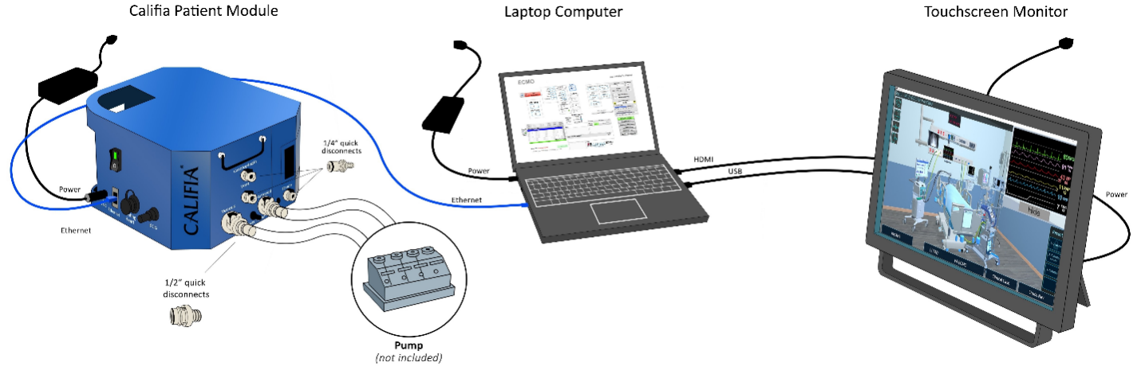

Figure 1.1. Califia Perfusion Simulator Setup

The CPM hydraulic ports, ‎Figure 1.2, connect to either a Heart Lung Machine (HLM), in the case of CPB, or an ECMO system.
CPM hydraulic ports | Description
Arterial | Main delivery port into the CPM. It connects to the oxygenator outflow line.
Venous | The CPM’s drainage port. It connects to a venous reservoir in the case of CPB or directly to the pump’s inlet port in ECMO circuit configurations.
Cardioplegia | Secondary deliver port into the CPM. Used for Cardioplegia delivery during CPB or as a second delivery port in hybrid ECMO circuit configurations.
Vent | Secondary drainage port. During CPB, it can connect to the Left Ventricle Vent pump.
Drain | Tertiary drainage port. It is used to drain the CPM’s reservoir during the teardown process.
Overflow | It provides runoff should the CPM’s reservoir overfill.
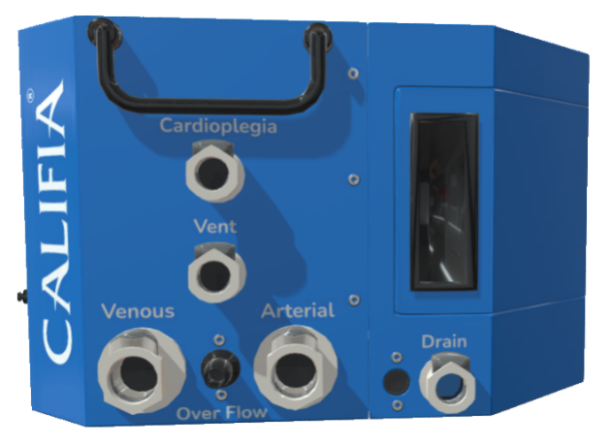

Figure 1.2. CPM Hydraulic Ports

CPM connections for Cardiopulmonary Bypass (CPB)

Figure 1.3 illustrates connections from a simplified CPB circuit to the CPM. Table 1.1 summarizes these connections.
HLM | CPM
Systemic blood pump | Arterial
Venous Reservoir | Venous
Cardioplegia delivery | Cardioplegia
LV Vent pump | Vent

Table 1.1 HLM connections to CPM

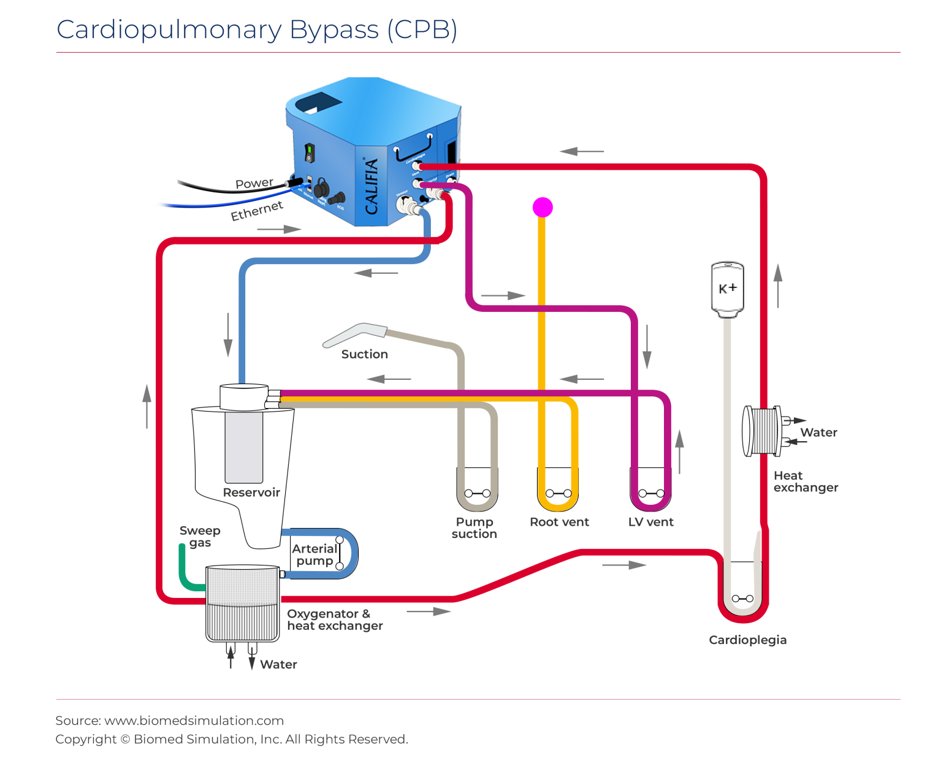

Figure 1.3 CPB connections to CPM
Note - If the Vent port is not used, connect a ¼” tubing segment and clamp it.



CPM connections for ECMO

    - VA ECMO - Figure 1.4 illustrates connections between a VA ECMO circuit and the CPM. Table 1.2 summarizes these connections.
ECMO | CPM | NOTES
Oxygenator output port | Arterial
ECMO Pump inlet | Venous
 | Cardioplegia | Connect these together
 | Vent

Table 1.2 VA ECMO connections to CPM

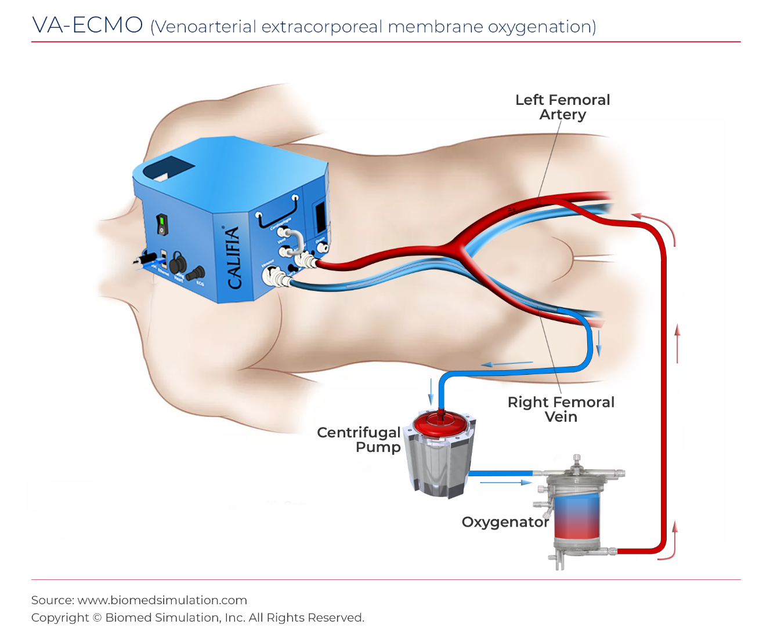
Figure 1.4 VA ECMO with CPM

    - VV ECMO --Figure 1.5, illustrates connections between a VV ECMO circuit and the CPM. Table 1.3 summarizes these connections.
ECMO | CPM | NOTES
Oxygenator output port | Arterial
ECMO Pump inlet | Venous
 | Cardioplegia | Connect these together
 | Vent

Table 1.3 VV ECMO connections to CPM

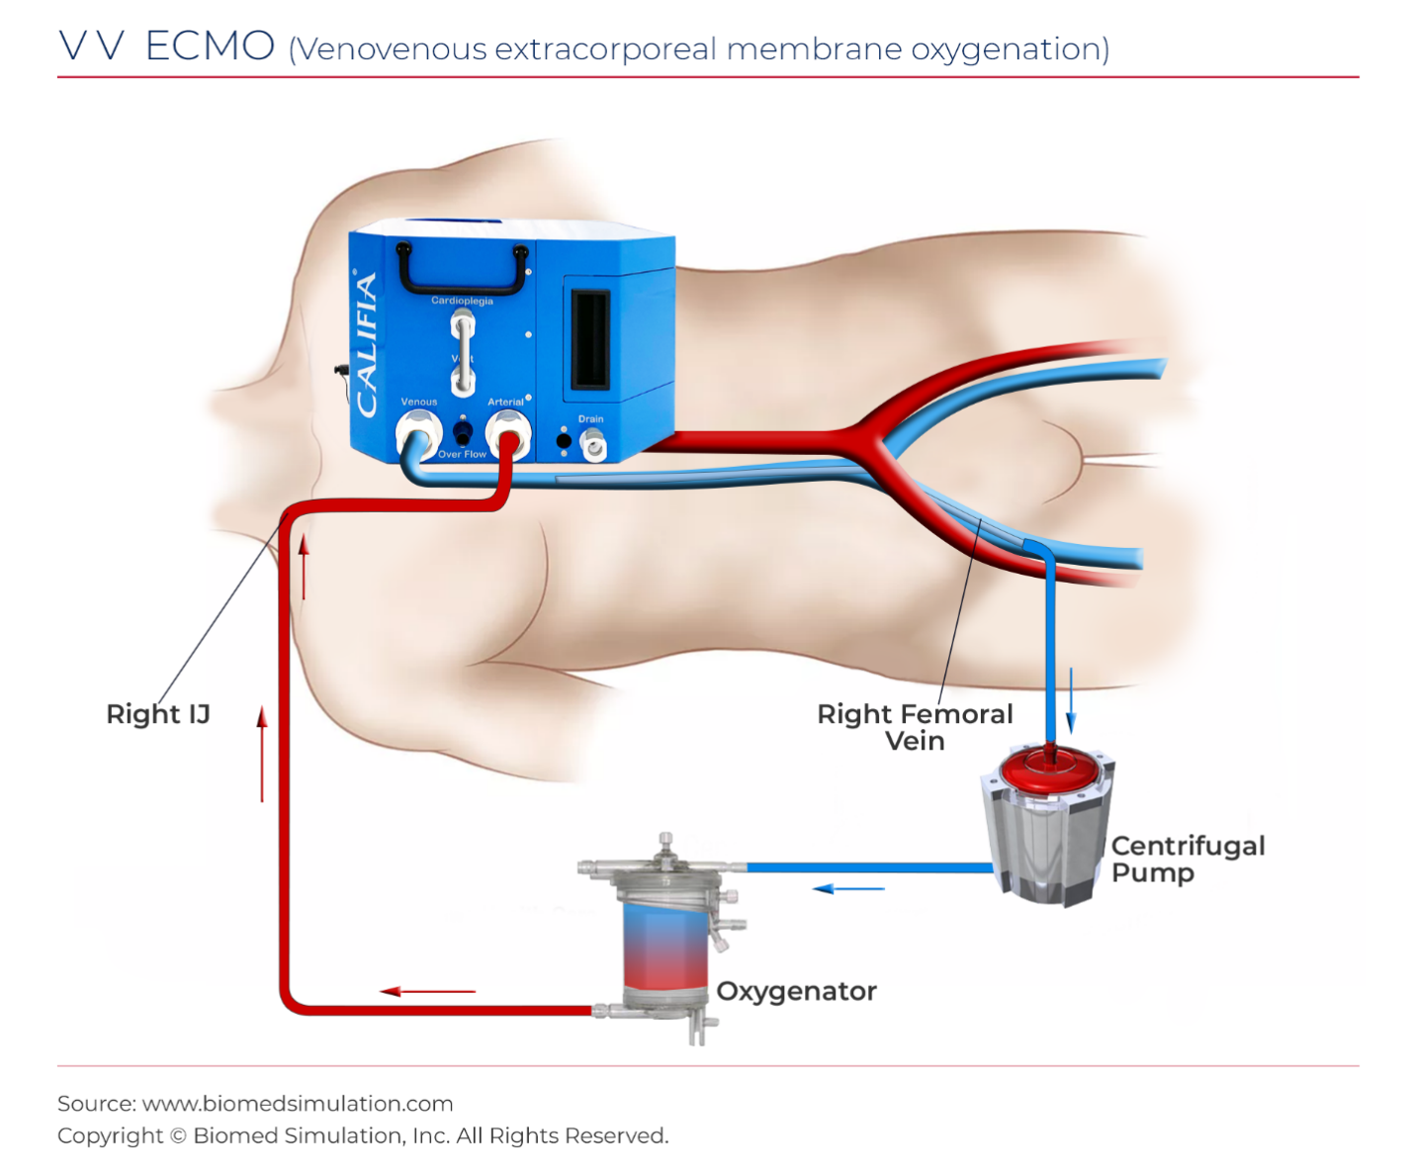

Figure 1.5 VV ECMO with CPM

    - VAV ECMO -Figure 1.6 illustrates connections between a VAV ECMO circuit and the CPM. Table 1.4 summarizes these connections.
ECMO | CPM | NOTES
Delivery main branch | Arterial
ECMO Pump inlet | Venous
Delivery IJ branch | Cardioplegia
 | Vent | Clamped tubing

Table 1.4 VAV ECMO connections with CPM

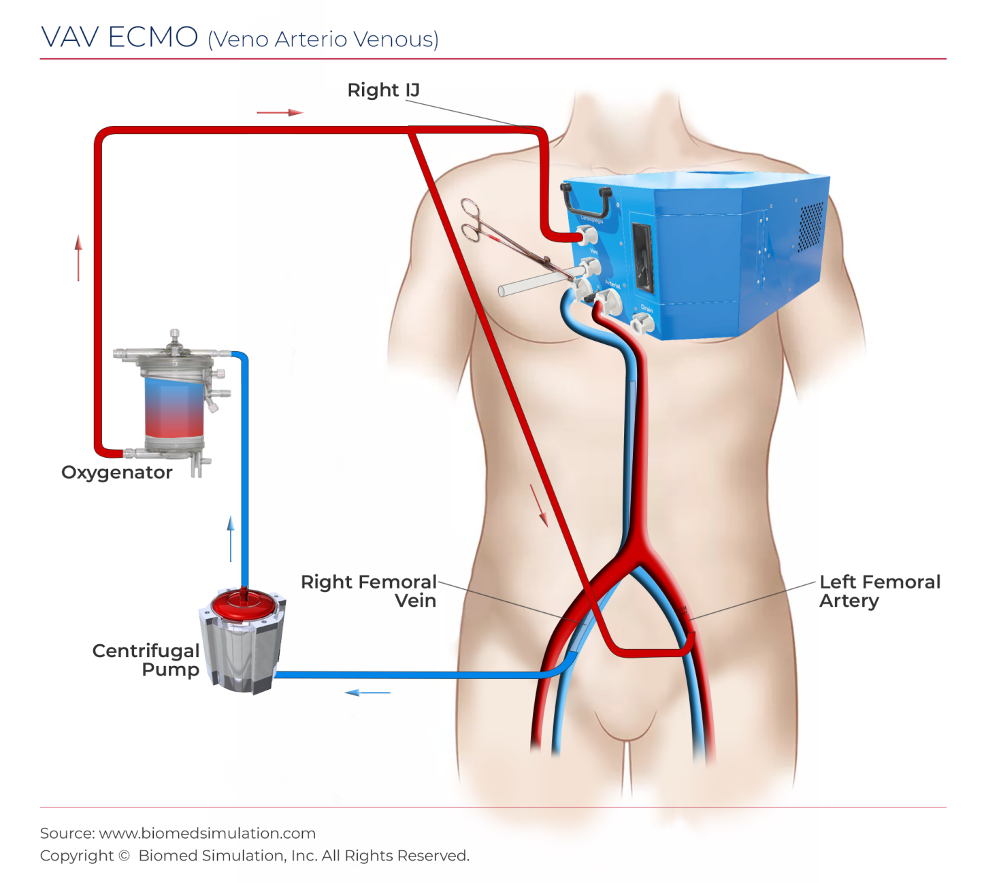

Figure 1.6. VAV ECMO with CPM

2

A brief tour of the Califia Simulator software
To launch the Califia Simulator software, double-click the Califia Simulator icon located in the laptop computer’s desktop. Refer to Figure 2.1.
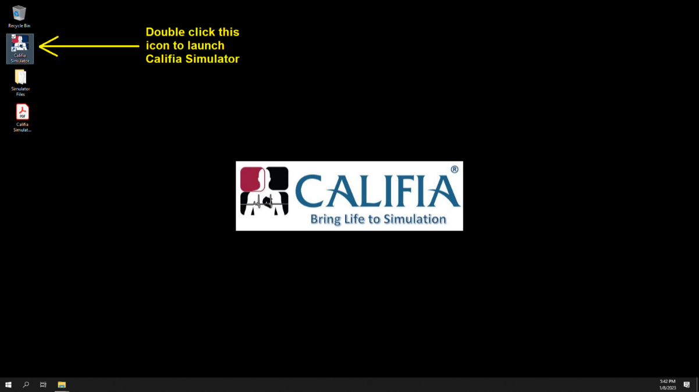
Figure 2.1. Califia Simulator desktop icon
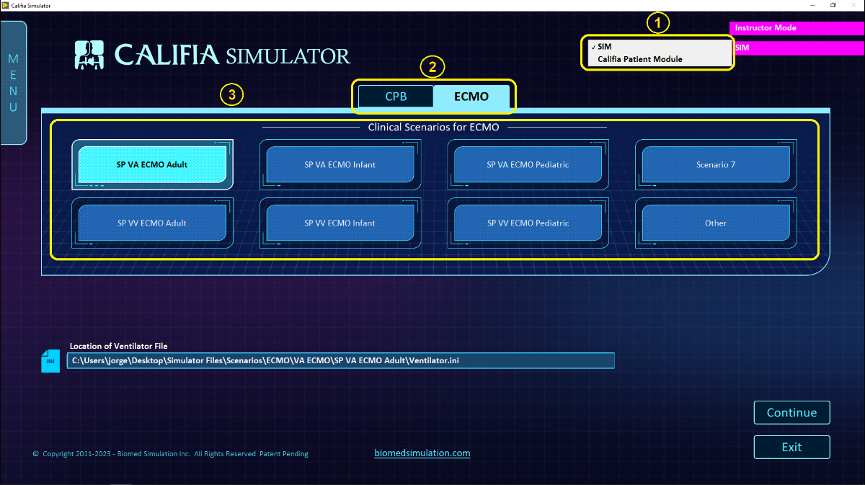

Figure 2.2. Califia Simulator Opening Screen

Modes of Simulation: SIM and CPM

Refer to ① in Figure 2.2.
SIM this mode does not use the Califia Patient Module. All relevant equipment, Heart Lung Machine (HLM) in CPB or ECMO circuit in ECMO, is virtualized and made accessible in the software.
Califia Patient Module this mode uses the CPM and real life support equipment such as a HLM or ECMO circuit. If the Califia Simulator software detects the CPM present, this selection becomes available.

Modes of Operation: CPB and ECMO

Refer to ② in Figure 2.2
Select either CPB or ECMO to step into the selected simulation application. The next step is to select a clinical simulation scenario then press the Continue button on the lower right of the window.

Clinical Scenario files

Refer to ③ in Figure 2.2.
Many of the buttons in the Clinical Scenarios section provide easy links to scenario files. For this Getting Started process, we will use one of the Standardized Patient scenarios.
For CPB, select the button labeled SP CPB Adult.
For ECMO, select the button labeled SP VA ECMO Adult.
Either of these simulation scenarios will configure the patient as an adult in need of either CPB or VA ECMO support respectively.

Instructor’s Panel

Figure 2.3 shows the Instructor’s Panel for CPB and ECMO side-by-side.
These panels have a similar layout. The CPB Instructor’s Panel shows its space divided into sections.
① refers to common numerical indicators and entry fields such as blood gas sampling values.
② is the scenario file and steps section.
③ shows the grouping of text fields.
④ displays a different top half based on the button selection.
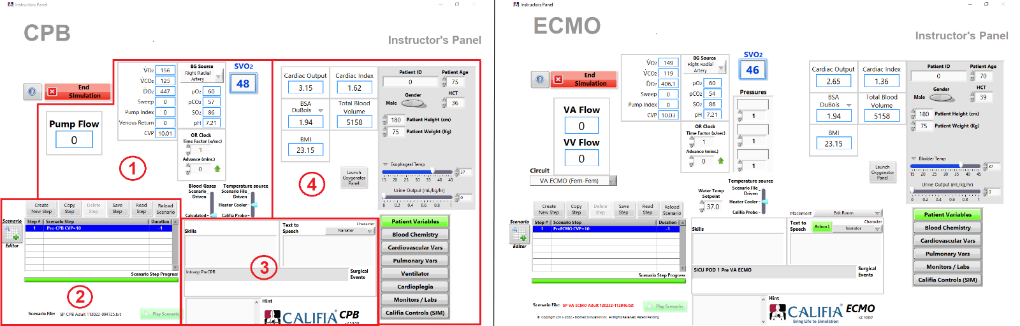

Figure 2.3 Instructor's Panels for CPB and ECMO respectively

Learner Screen

Figure 2.4 shows the Learner Screen for CPB and ECMO side-by-side.
As in the case of the Instructor’s Panels, these screens have a similar layout. Refer to the numbers in the image for the following descriptions
① displays the patient’s vital signs in the form of traces and numerically
② is an area used to display relevant medical device panels like inline blood gas analysers, heater-coolers and clotting timers.
③ is a blood sampling report. This is a floating panel that can be moved to different locations. There are other similar floating panels available for either CPB or ECMO.
④ refers to the gas blender elements: Sweep and Oxygenator FiO2.
⑤ is the bottom ribbon with access to panels and options such as Alarms and Media panels.
⑥ is shown in the ECMO learner screen and refers to the Ventilator settings area.
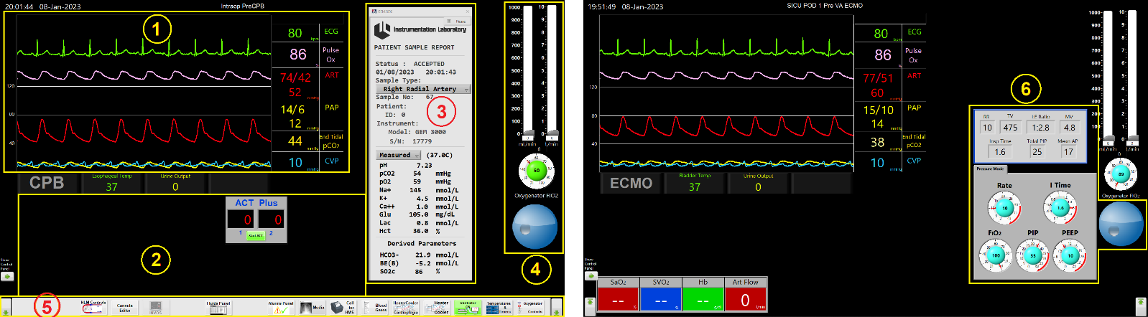

Figure 2.4 Learner Screen for CPB and ECMO respectively

The Califia 3D ICU environment (ECMO only)

Figure 2.5 shows the 3D Intensive Care Unit (ICU), available for ECMO simulation. The learner can navigate the environment and interact with the medical devices in the space.
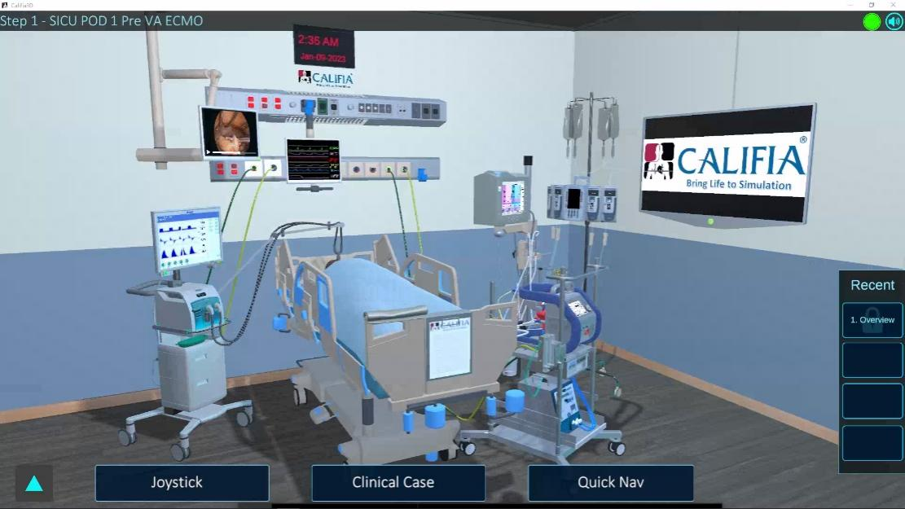

Figure 2.5 Califia 3D ICU (ECMO only)

3

Prepare the Califia Patient Module

Priming CPM

Prepare the CPM with tubing connections, refer to Figure 3.1
- The Arterial and Venous ports attach to ½” tubing.
- The Cardioplegia and Vent ports attach to ¼” tubing.
- Make each tubing segment at least 6” in length. Clamp all 4 tubings to avoid leaking water.
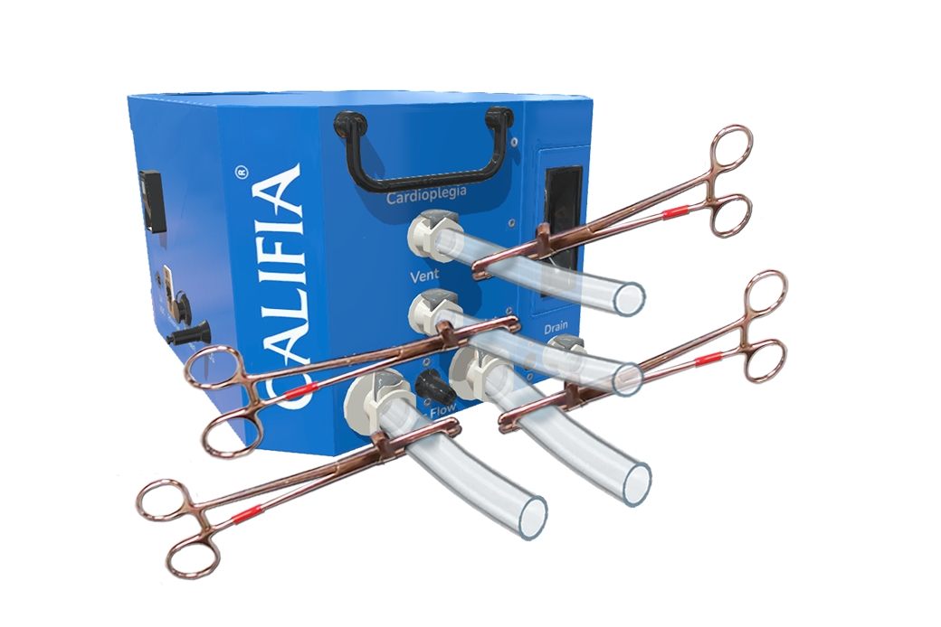

Figure 3.1 CPM with tubing clamped
Power ON the CPM, wait about 30 seconds and select the Califia Patient Module simulation mode in the Opening Screen, then press Continue to step into either CPB or ECMO per your preference.

Refer to Figure 3.2 to prime the CPM.
① Use a pitcher to carefully pour about 2.5 Liters of water into the CPM’s reservoir.
  - Notice patient’s vitals such as arterial pressure and central venous pressure increase in value; in essence, the vitals correspond to those of a living patient.

  - Ensure all tubing is clamped to avoid any water leak
② Open the side door to align the silicon tubing in peristaltic pump’s raceway

③ Do not operate peristaltic pump while adjusting tubing
④ Close peristaltic pump lid
⑤ Close side door
⑥ In the Instructor’s Panel » Califia Controls section, press the Pressurize button to operate the peristaltic pump and prime the CPM. After about 5 minutes of operation, press the Pressurizing button to stop the pump, the CPM should be primed.
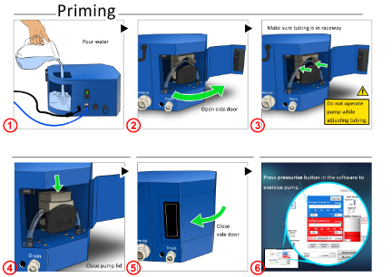

Figure 3.2. Priming CPM
High flow rates at lower pressure are achieved with the CPM placed 18” to 20” above venous reservoir (CPB) or pump inlet (ECMO).

Return to the Opening Screen

If you wish to choose a different simulation scenario as instructed in one of the next two next sections, press the End Simulation button in the Instructor’s Panel to return to the Opening Screen.

4

Let’s go on pump! – a CPB simulation
This chapter steps through a CPB simulation. You can follow along.

Approximately 60 minutes to complete this chapter.

SIM vs Califia Patient Module

Refer to Figure 4.1, ①.
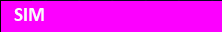 | Sections in this chapter headlined with this image refer to software-only simulation. No CPM or real pump is involved.
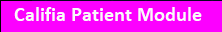 | Sections in this chapter headlined with this image use a Heart Lung Machine connected to the CPM.

Use a Standardized Patient scenario

Select one of the three SP CPB scenarios available, Figure 4.1, ②:
- SP CPB Adult
- SP CPB Infant
- SP CPB Pediatric
Press Continue button, ③, to step into the simulation.
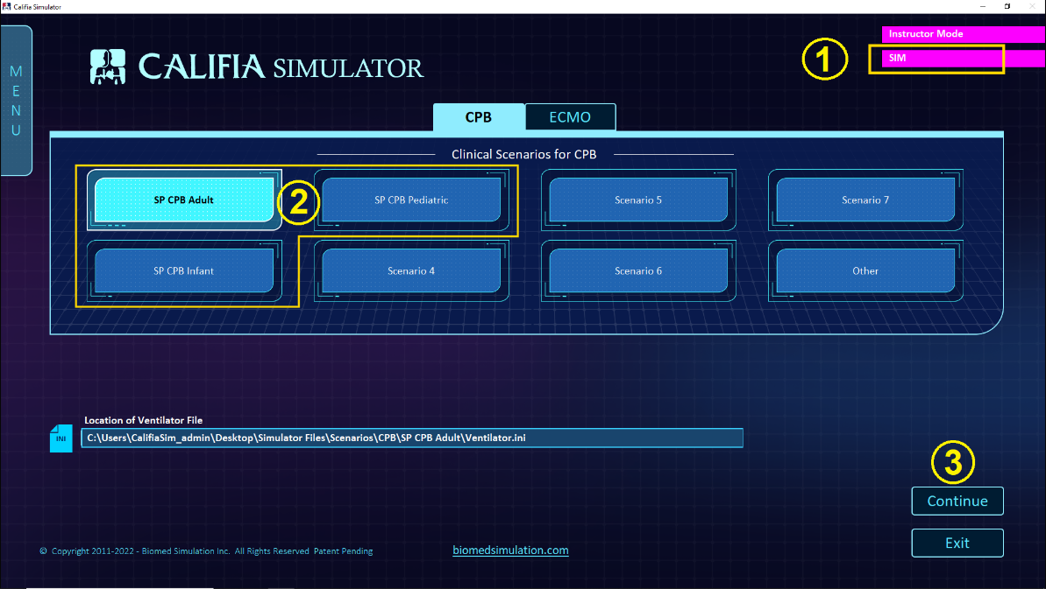

Figure 4.1. Opening Screen » CPB mode

Patient Demographics

Refer to Figure 4.2 review and change the following:
① Age
② HCT
③ Gender
④ Weight
⑤ Height
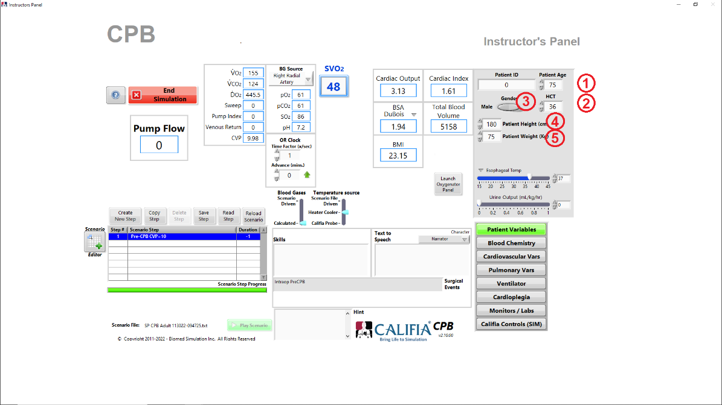

Figure 4.2. Patient demographics in Instructor's Panel

CVP Gain

In Instructor’s Panel, press the Calibration Panel button under Califia Controls to bring up the Califia Calibration Panel, Figure 4.3. Set CVP Gain as dictated in Table 4.1
BSA (m²) | CVP Gain
< 1 | 3.5
Between 1 & 2 | 3.0
> 2 | 2.5

Table 4.1. BSA vs CVP Gain

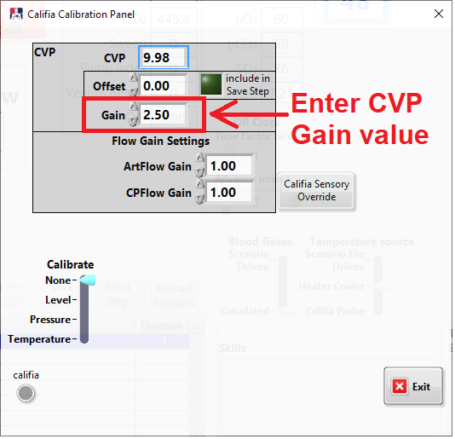

Figure 4.3. Califia Calibration Panel > CVP Gain

CVP

Set CVP to 10 mmHg
Fill Califia’s Reservoir until CVP is 10 mmHg, ① in Figure 4.4
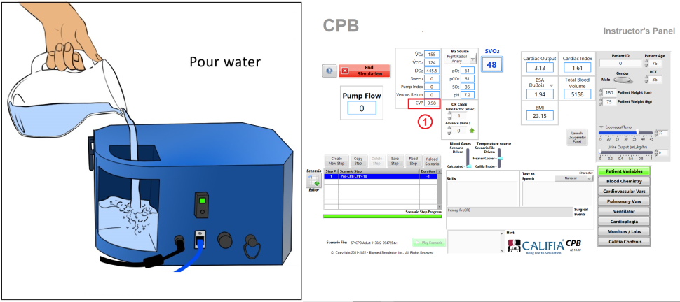

Figure 4.4. Fill CPM with water to match target CVP

Refer to Figure 4.5, go to Instructor’s Panel » Califia Controls
① Enter 10 for Target CVP then press <Enter>
② Volume in the virtual Califia’s Reservoir changes until CVP reaches 10, ③.
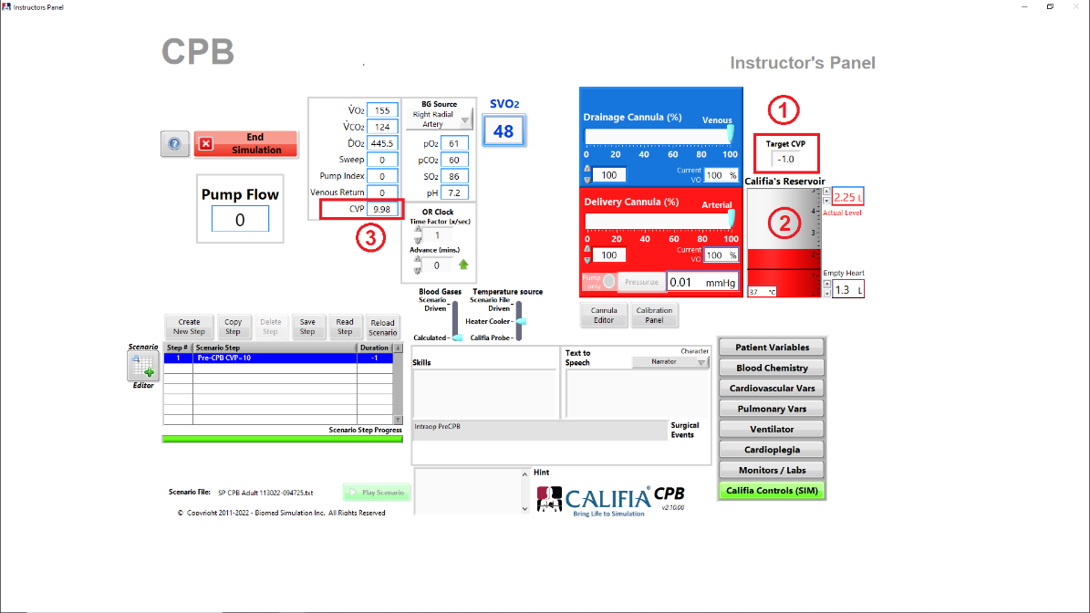

Figure 4.5. Set Target CVP in SIM mode

Arterial Pressure

Refer to Figure 4.6, in Instructor’s Panel » Cardiovascular Vars,
① Press Set Arterial Pressure button.
② Specify desired Systolic and Diastolic Arterial Pressures.
③ Press Target button.
④ It takes a few seconds to find values for LV Contractility and SVR.
⑤ Press Save Step to save all changes to scenario file.
Close Model Settings panel once targetting is complete.
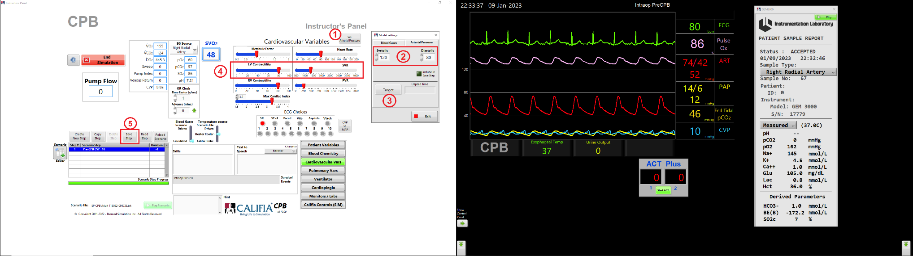

Figure 4.6. Set Systolic and Diastolic Arterial Pressure

Blood Gases

Refer to Figure 4.7, go to Instructor’s Panel » Blood Chemistry.
① Press Calculate Desired Gases button
② Specify desired pO2, pCO2 and pH for arterial blood
③ Press Target button
④ It takes several minutes to find values for HCO3, Dead Space and Pulmonary Shunt Fraction, the last two parameters are in the Pulmonary Vars section.
⑤ Press Save Step to save all changes to scenario file.
Close Model Settings panel once targetting is complete.
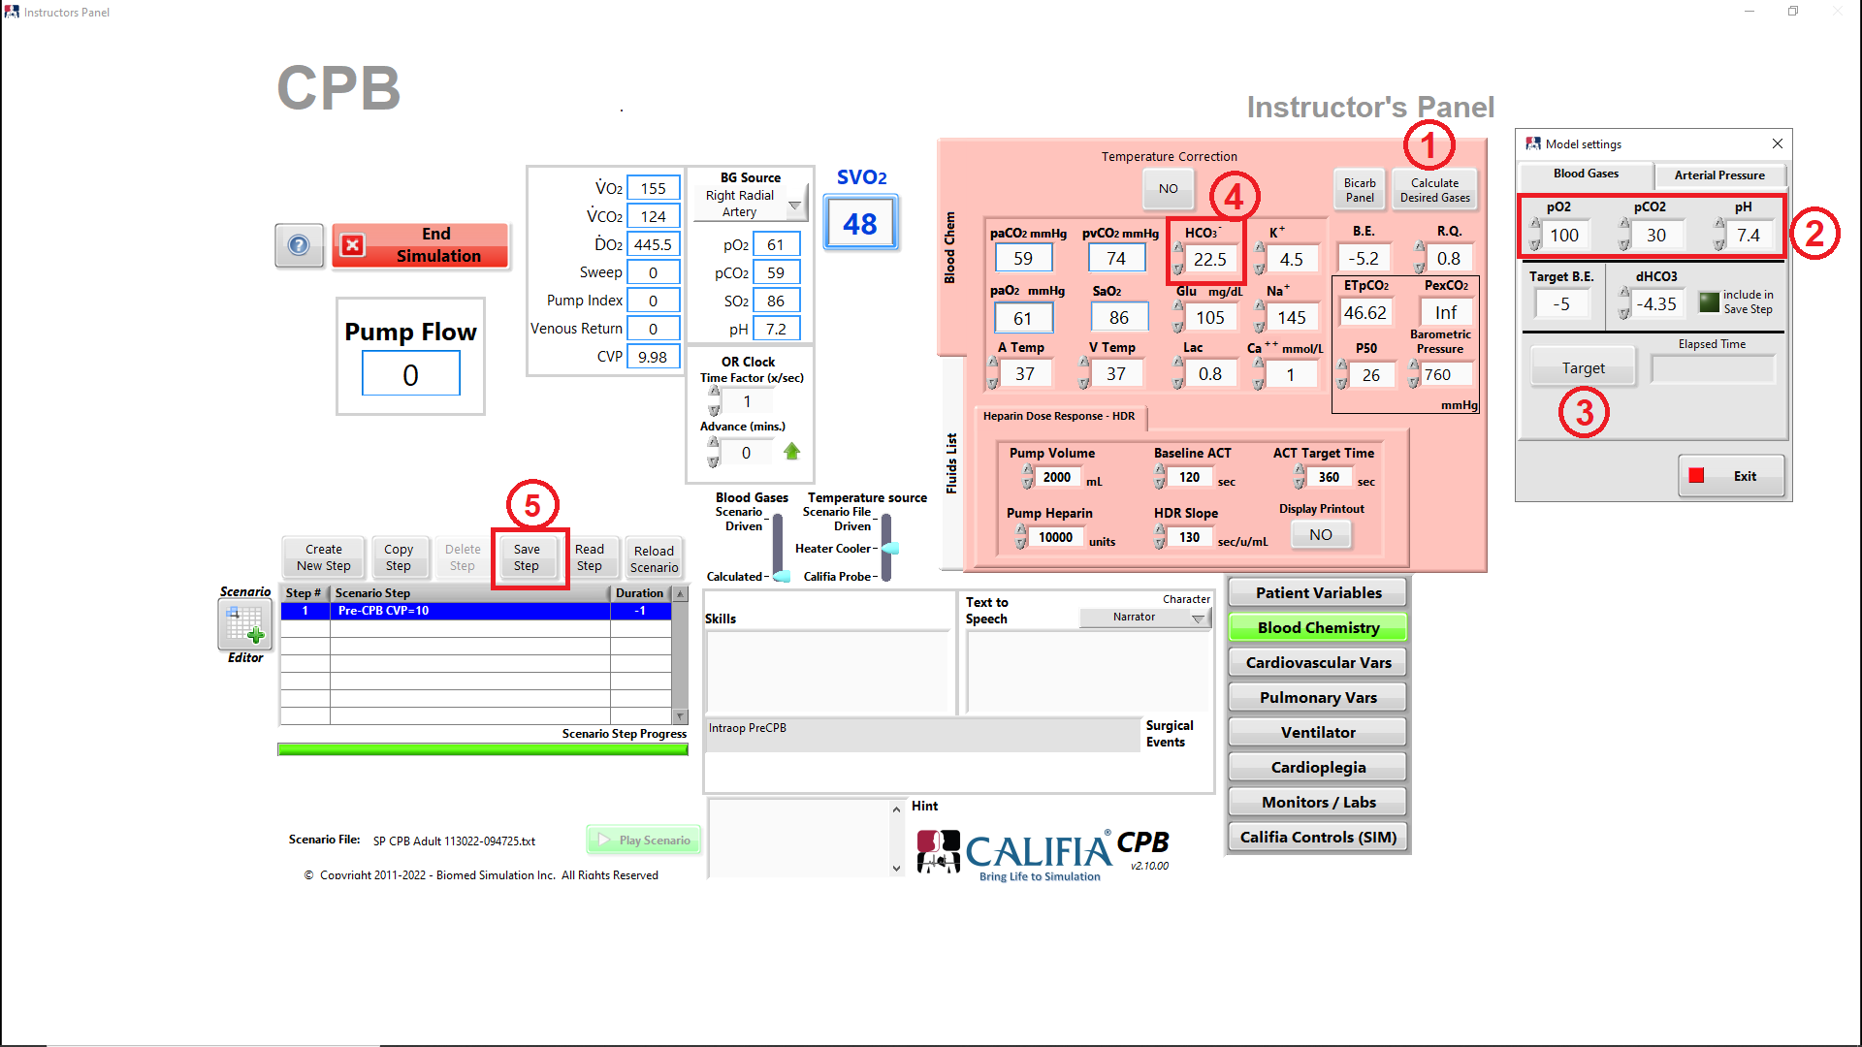

Figure 4.7. Set Blood Gases

Select Delivery and Drainage Cannulas

Refer to Figure 4.8 to select Delivery (arterial) and Drainage (venous) Cannulas. In Instructor’s Panel » Califia Controls,
① Press Cannula Editor button.
②a In Cannula Editor, select a Delivery Cannula from drop-down list then press Apply button.
③a Cannula label and corresponding valve opening is shown.
②b Change to Drainage Cannula, select cannula from drop-down list then press Apply button.
③b Cannula label and corresponding valve opening is shown.

Exit Cannula Editor
Pressure-Flow profiles for cannulas are modeled using respective electromechanical valves in CPM. The same performance profiles are also used in SIM mode.
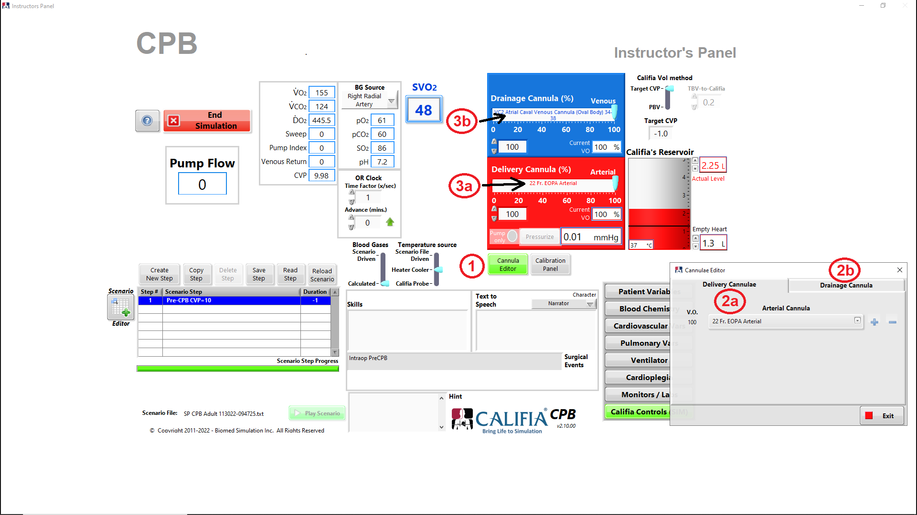

Figure 4.8. Cannula selection

Set Gas Blender

Refer to Figure 4.9, gas blender is set in the learner screen.
① Bring up bottom ribbon and select Oxygenator Controls button
② Set Gas Sweep Rate
③ Set Oxygenator FiO₂ by pressing green button then turning blue knob
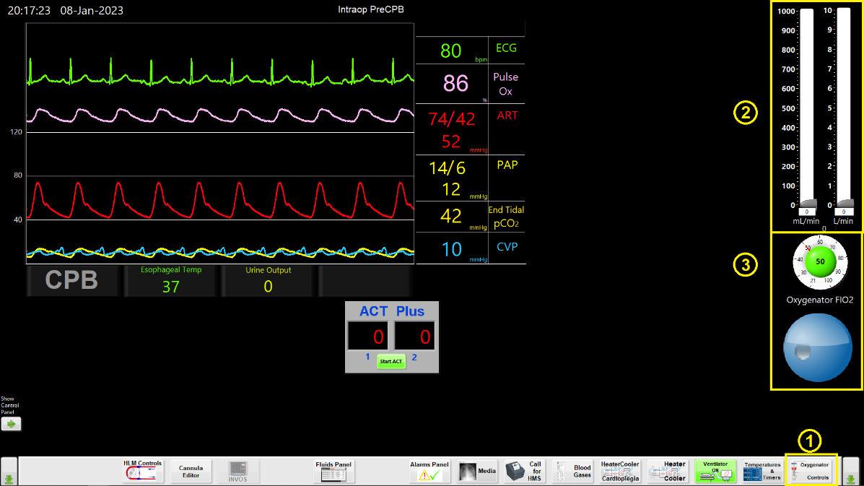

Figure 4.9 Set Gas Blender

Let’s go on pump!

Remove clamp on venous drainage line to drain patient while flowing using systemic pump.
Notice Arterial Pressure and CVP values decreasing as patient transitions support from native heart to heart lung machine, Figure 4.10.
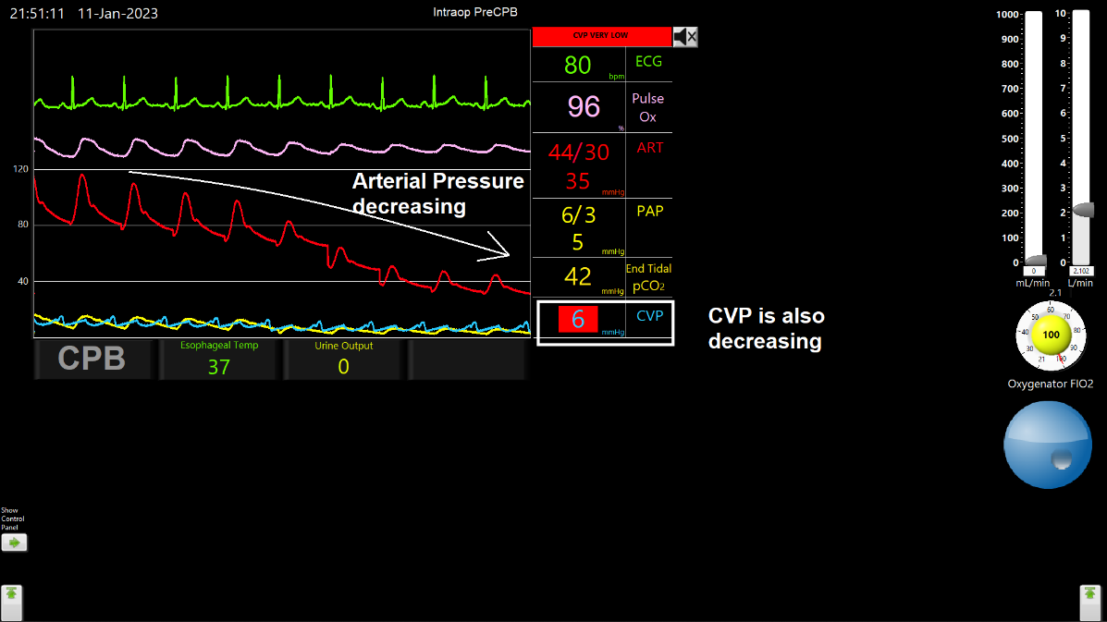

Figure 4.10 Arterial and CVP decreasing

Prime virtual circuit, refer to Figure 4.11
Bring up bottom ribbon
① Press Fluids Panel button
② Press HLM Controls button
In Fluids Panel
③a Select Crystalloid from Fluids drop-down menu
③b Enter 1000 mL of Volume
③c Light up the Priming button
③d Press Apply button
④ Notice Venous Reservoir fills up with this priming volume
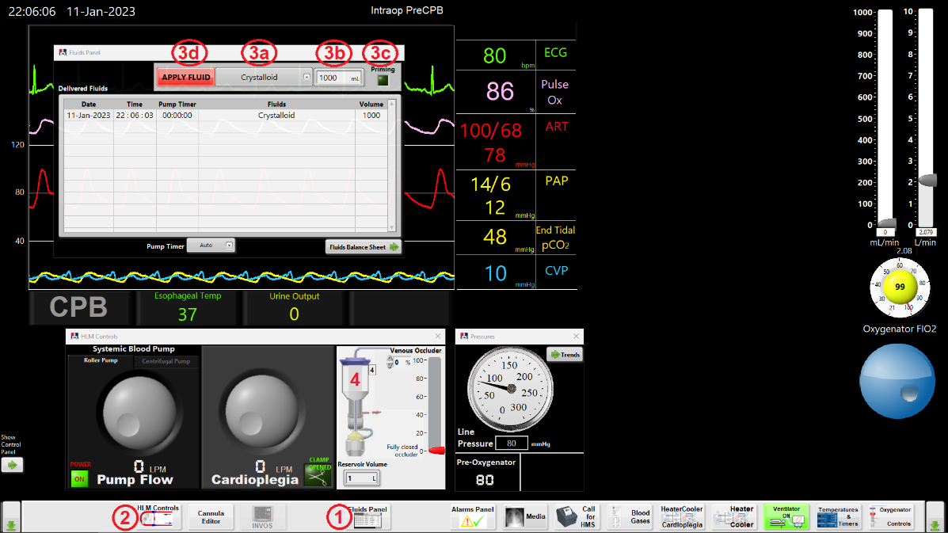

Figure 4.11 Prime circuit using Fluids Panel

To go on bypass, refer to Figure 4.12,
① Gradually open Venous Occluder
② Start increasing systemic pump flow
Virtual systemic pump is a roller pump
③ Watch for arterial pressure waveform flattening though as flow is increased, mean pressure rises
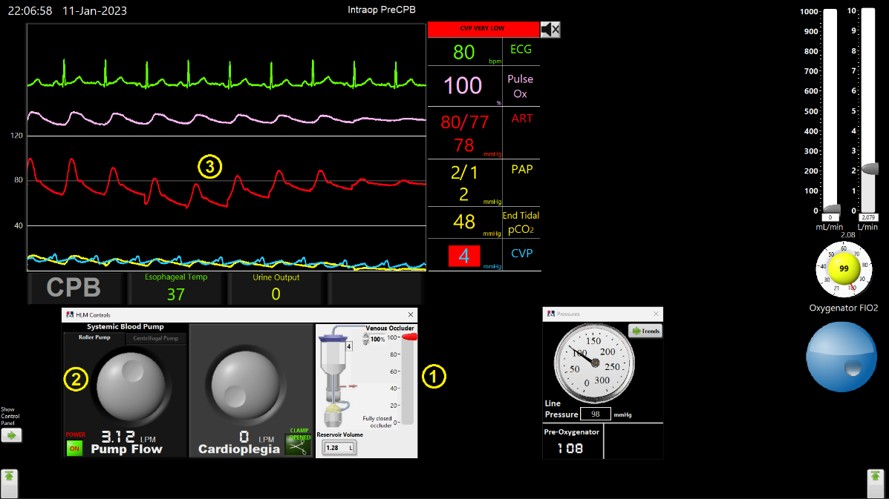

Figure 4.12 Starting bypass (SIM)

Give Cardioplegia
Refer to Figure 4.13, in Instructor’s Panel » Cardioplegia,
① Set slider to Ante (Antegrade Cardioplegia delivery)
② Close X Clamp
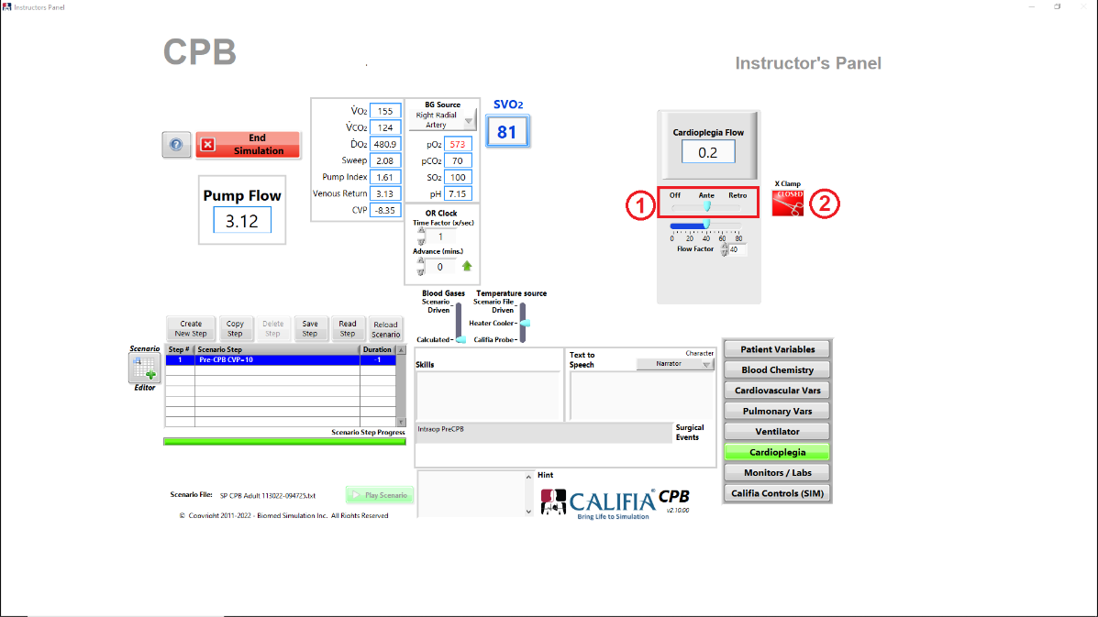

Figure 4.13 Prepare for Cardioplegia delivery

Flow into Cardioplegia port. As flow is registered in the simulation software, the heart ECG will step through various patterns until the heart is completely arrested, Figure 4.14
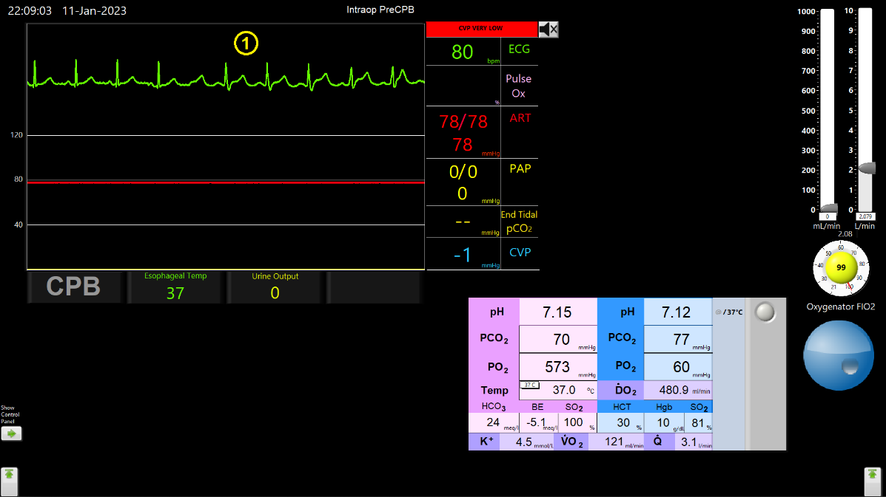

Figure 4.14 Heart ECG under Cardioplegia delivery

Refer to Figure 4.15:
① Close X Clamp in HLM Controls panel
② Increase Cardioplegia pump flow
③ Notice ECG pattern change
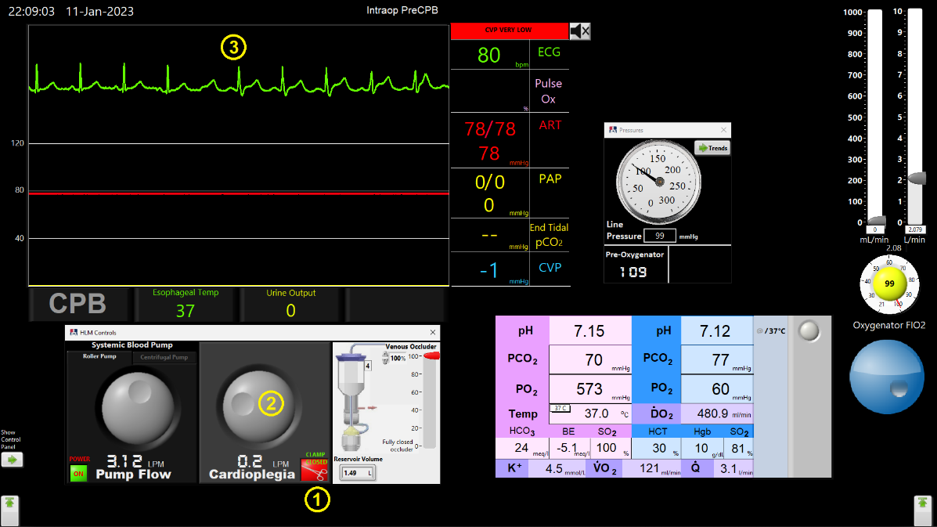

Figure 4.15. Heart ECG under Cardioplegia delivery (SIM)

Event: Cannula malposition
Refer to Figure 4.16, in Instructor’s Panel » Califia Controls,
① Set Delivery Cannula (%) slider to about 25%
② Arterial line pressure increases
cc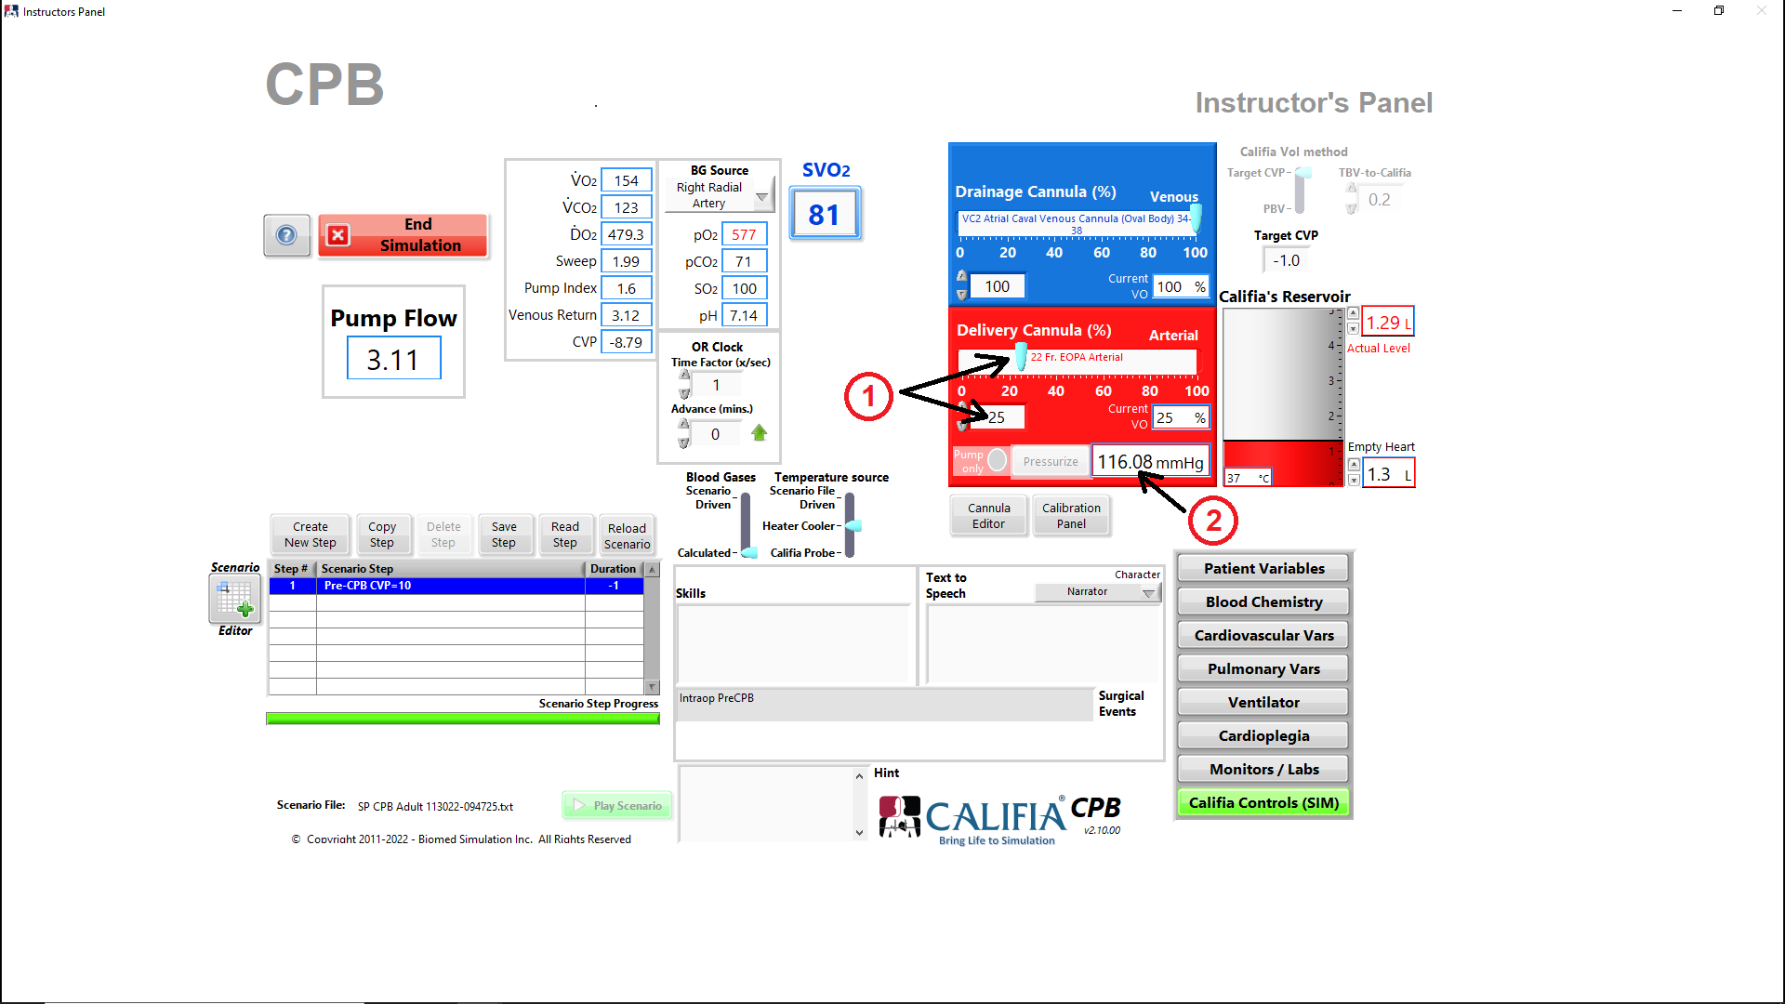

Figure 4.16. Arterial Cannula set to 25% opened

Arterial line pressure should report a high value due to high resistance generated by the smaller arterial valve opening, Figure 4.17.
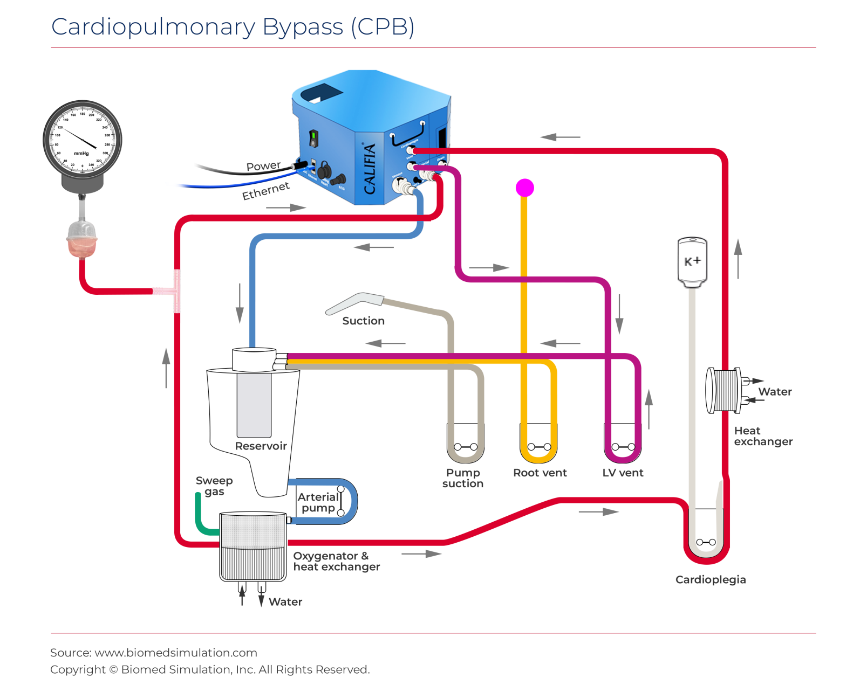

Figure 4.17. High line pressure
Main pump type
Roller pump
High line pressure is expected until the pump’s speed is lowered.
Centrifugal pump
High line pressure should be experienced momentarily, flow rate slows down and pressure decreases accordingly.

Due to the high resistance generated by the smaller arterial valve opening, the arterial line pressure displayed using the pressure panel is very high, Figure 4.18
Line pressure (post-Oxygenator): 168 mmHg
Pre-Oxygenator pressure: 178 mmHg
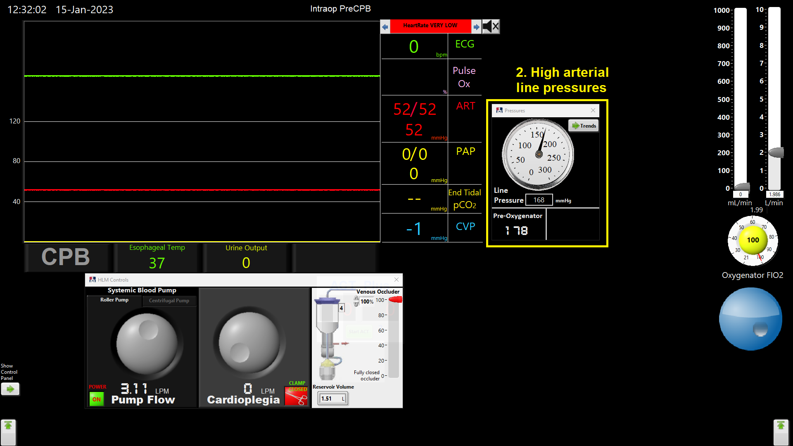

Figure 4.18. High arterial line pressures (SIM)

Set Delivery Cannula (%) back to 100% once the event is resolved.

Remove Cross Clamp

Refer to Figure 4.19
① Open Cross Clamp in Instructor’s Panel » Cardioplegia
② Notice ECG pattern return to activity, ending in SR.
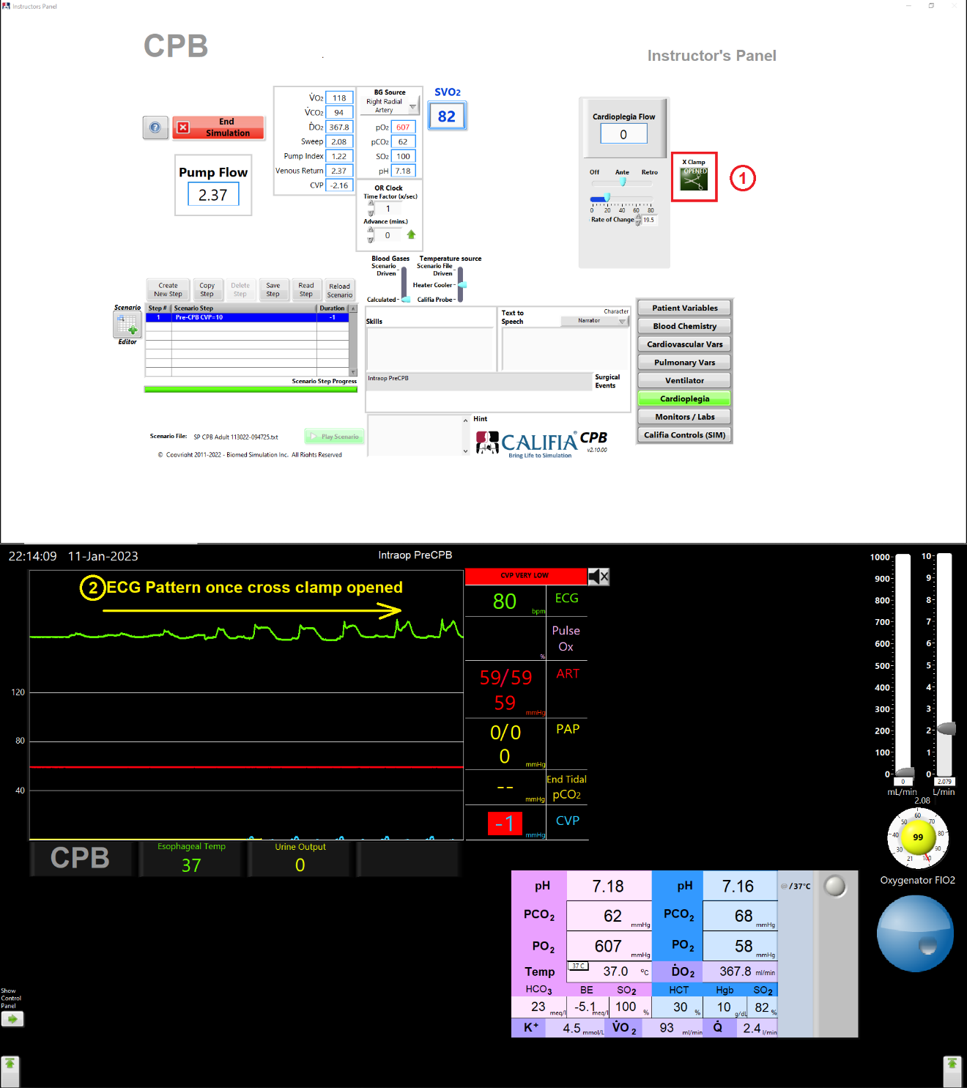

Figure 4.19. Open Cross Clamp

Refer to Figure 4.20
① Open Cross Clamp in HLM Controls panel
② Notice ECG pattern return to activity, ending in SR.

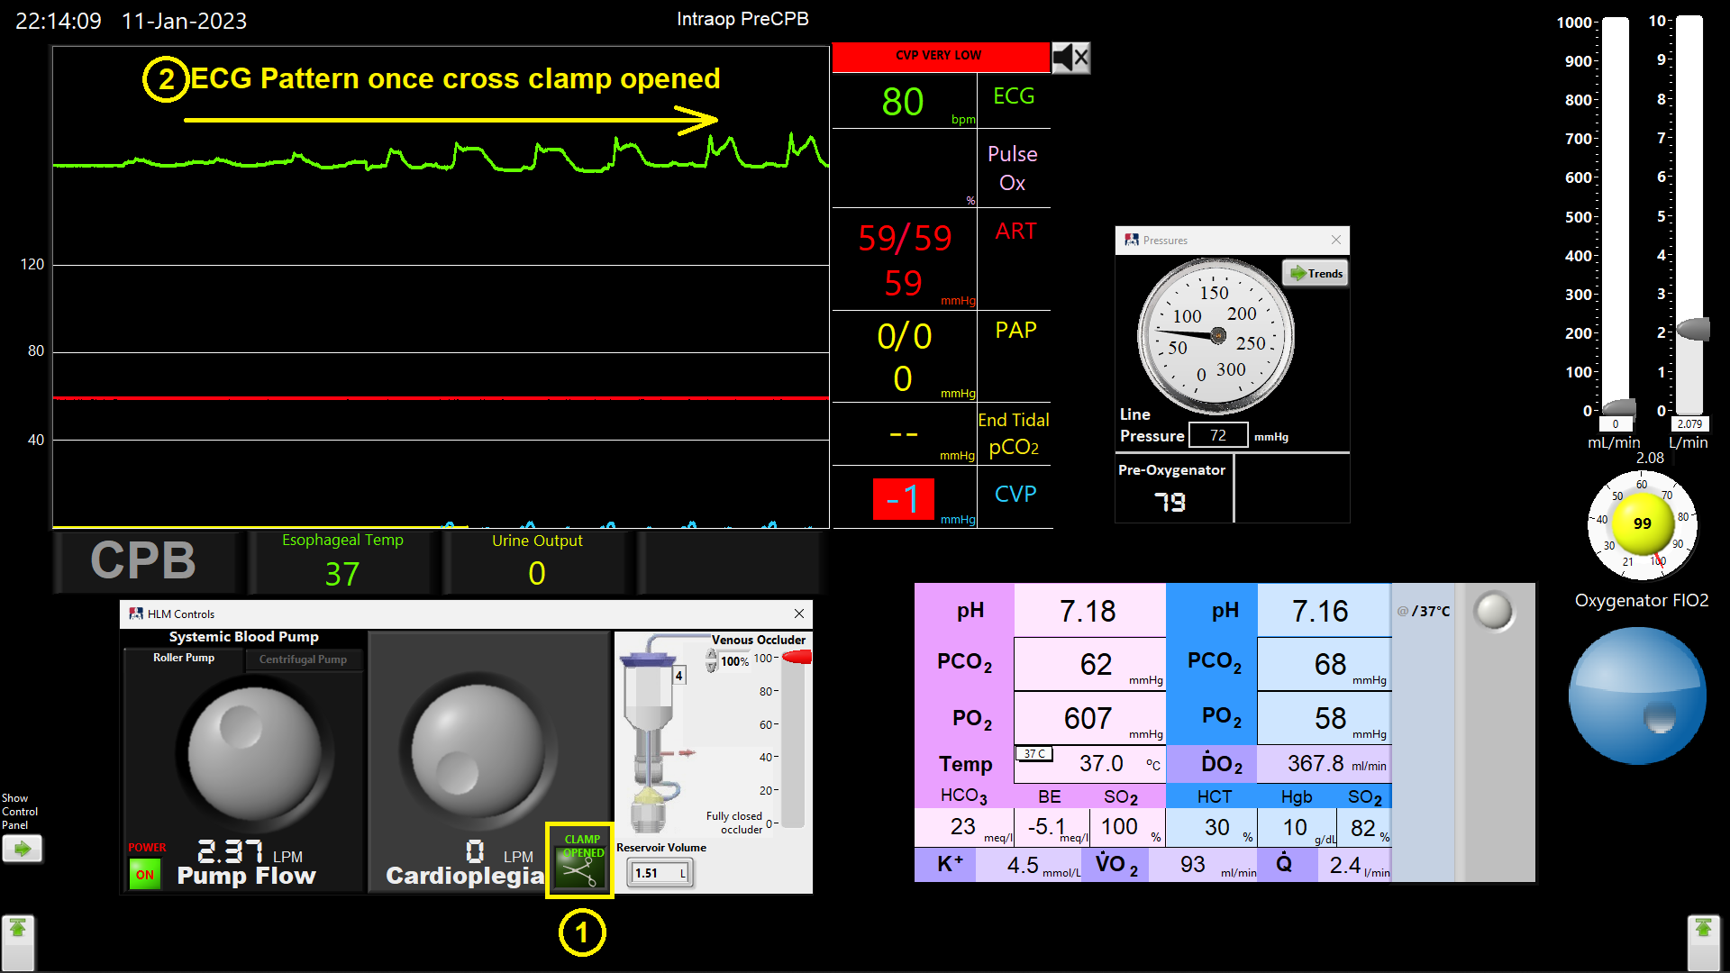

Figure 4.20. Open Cross Clamp (SIM)

Come off pump!

Refer to Figure 4.21
Start weaning by partially occluding venous drain and filling patient.
① Notice patient’s heart starts to eject and venous pressure increases
Come-off systemic pump as patient’s arterial pressure returns to normal and CVP meets target value.
② Heart has taken over full body perfusion and CVP is normal value
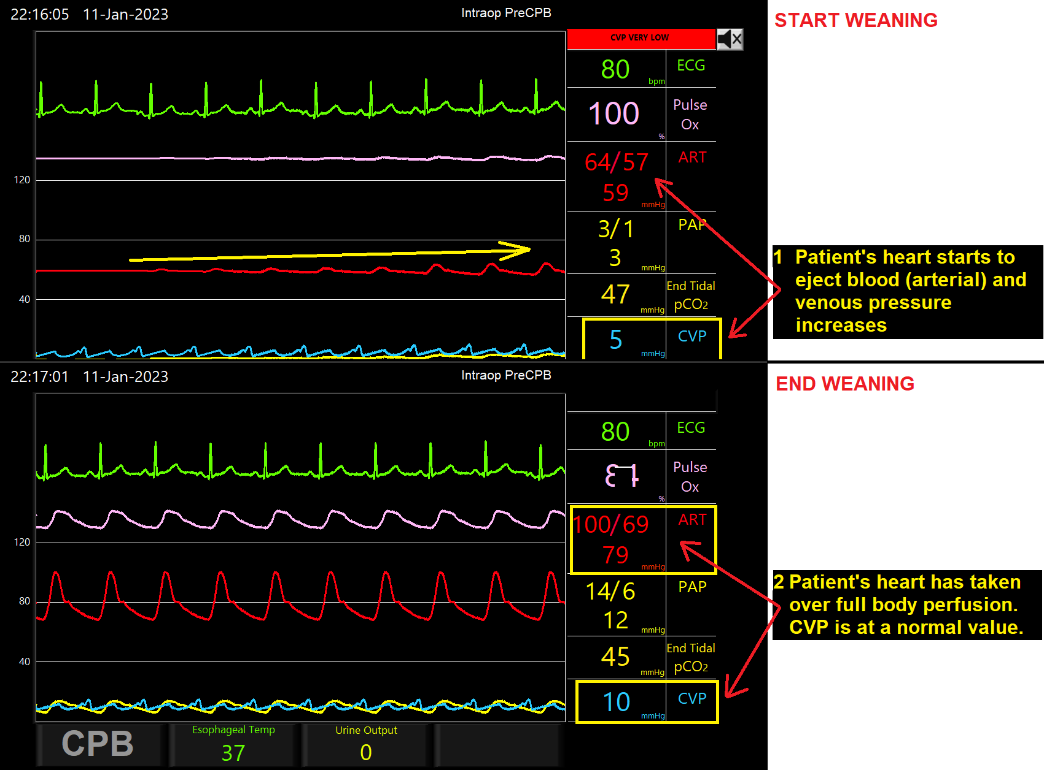

Figure 4.21 Wean off pump

Refer to Figure 4.22.
① Start weaning by partially occluding venous drain and filling patient.
② Notice patient’s heart starts to eject and venous pressure increases
③ Come-off systemic pump as patient’s arterial pressure returns to normal and CVP meets target value.
④ Heart has taken over full body perfusion and CVP is normal value
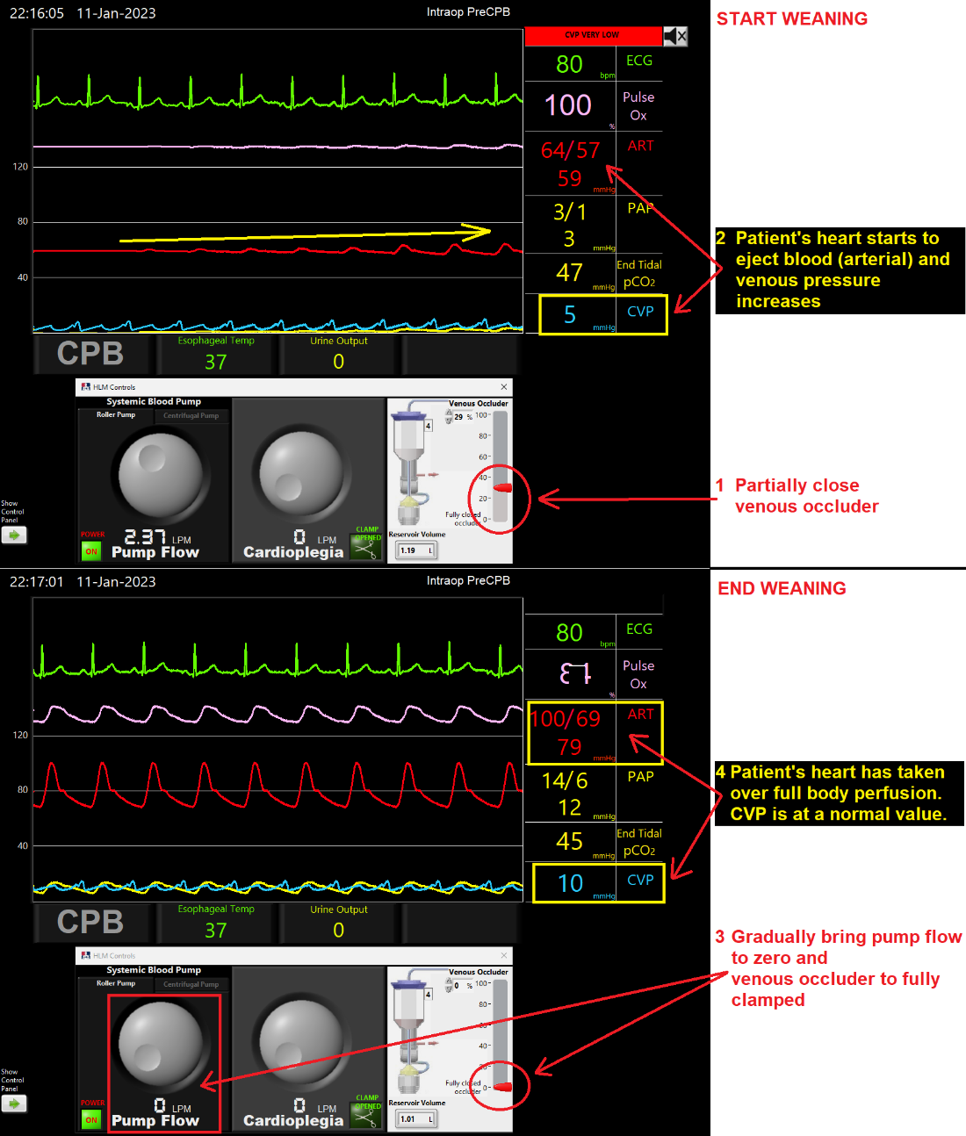

Figure 4.22. Wean off pump (SIM)

Return to Opening Screen
Refer to Figure 4.23, press End Simulation button, confirm request to return to Opening Screen.
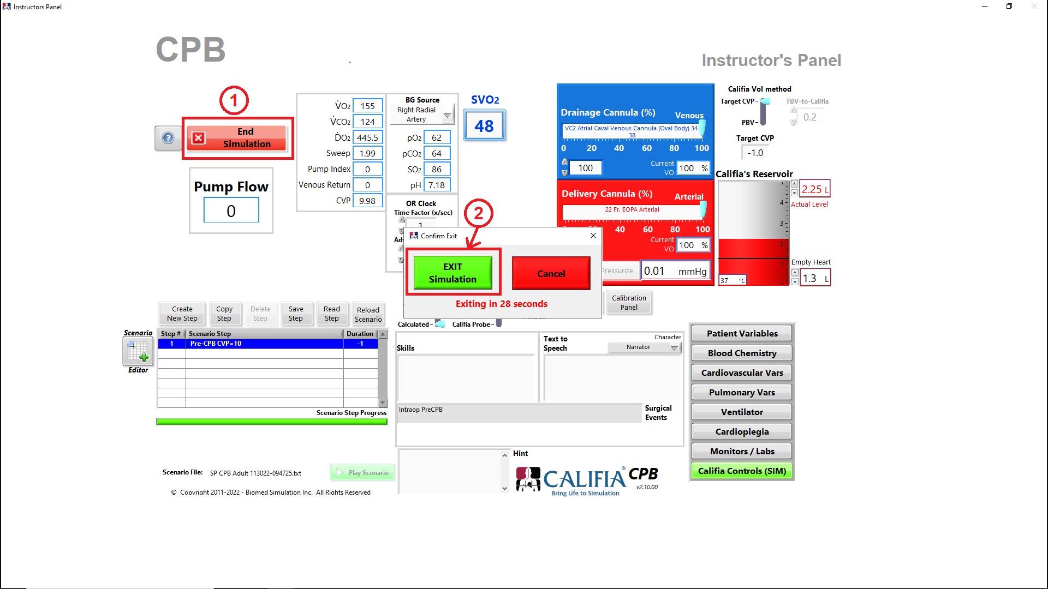

Figure 4.23. End Simulation

Create a CPB Simulation Scenario File
In this section, we will repeat the CPB case presented in this chapter however we will save all stages into a scenario file.

Access Scenario Editor -
Refer to Figure 4.24, Press MENU button, ①, followed by Scenario Editor button, ②.
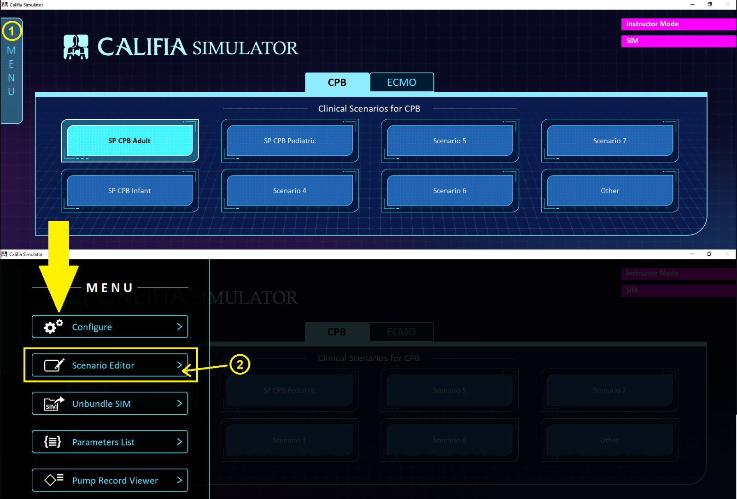

Figure 4.24. Access MENU in Opening Screen then Scenario Editor

Save Scenario File -
Refer to Figure 4.25, in Scenario Editor,
① Press File menu selection
② Select Save As….
③ Enter a new scenario file name such as Getting Started – CPB Scenario
This name is used to create a folder which will host the scenario file and ventilator.ini file
[Optional] – the Button Selector defaults to Other however a different button can be programmed to be associated with the new scenario file
④ Press the Create button to complete the new scenario file creation
Notice the Scenario Editor title reflects the new folder location and file name
⑤ Once new scenario file and folder created, return to File menu and press Close
Press Close button to close the MENU bar, this step is not shown.
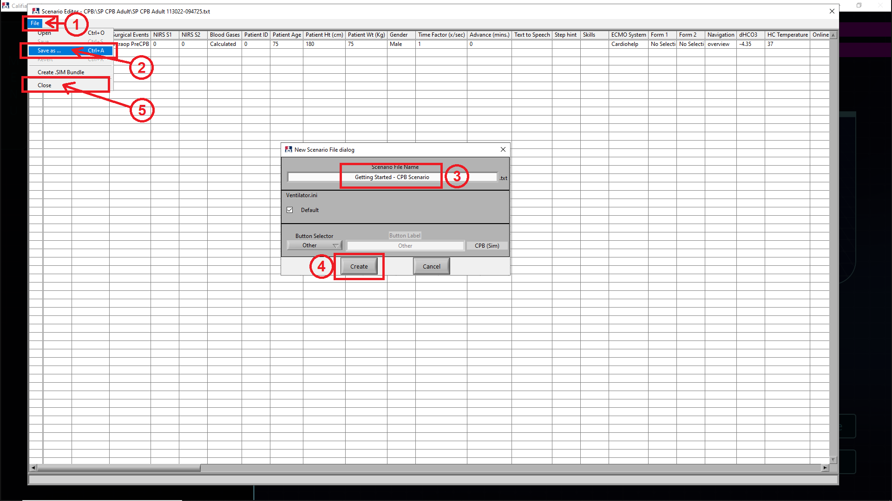

Figure 4.25. Save As... in Scenario Editor

New scenario file in Opening Screen -
Refer to Figure 4.26, Opening Screen
① Location of Scenario File points to the newly created Scenario File
② The selected button is Other as specified in the Save As… dialog
③ Press Continue button to load new scenario file
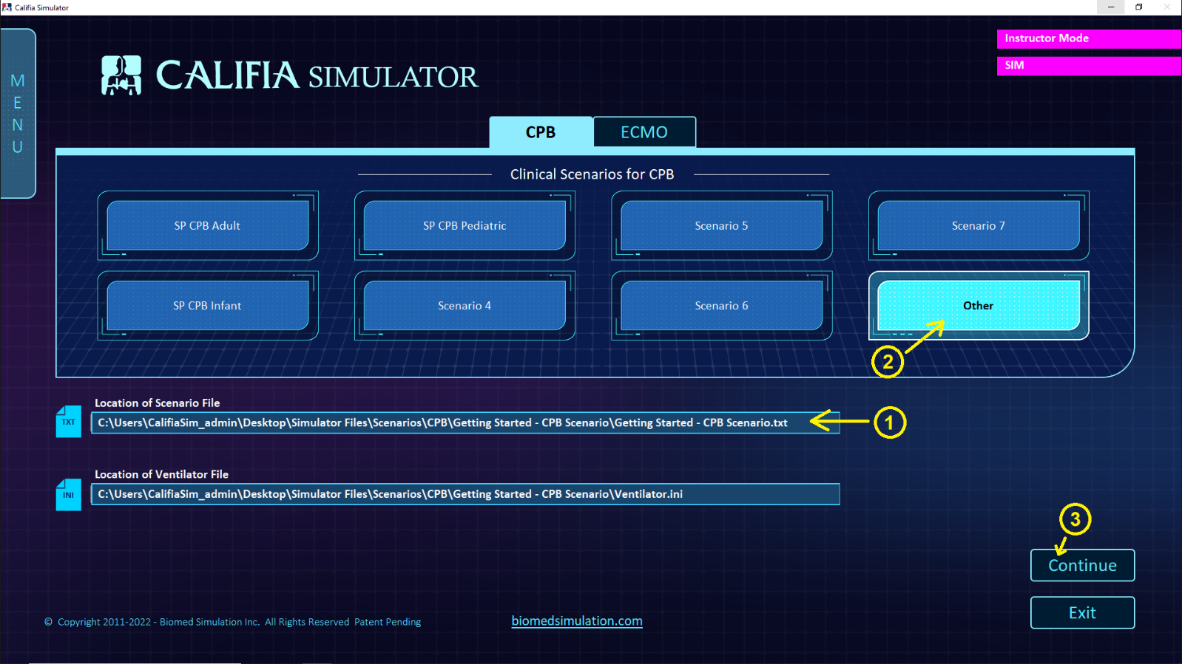

Figure 4.26. Opening Screen - New Scenario File

Scenario File Step 2: Select cannulas -
The original scenario file was saved with patient’s blood gases configured as desired, Section 4.7. [Blood Gases]
Next is to select cannulas. Follow these steps in Instructor’s Panel, refer to Figure 4.27
① Press Create New Step
② Step #2 is added to scenario table; type Select cannulas for Scenario Step then press <Enter> on keyboard or click away with the mouse
3 Follow steps in Section 4.8 to select cannulas
④ Press Save Step** button
** refers to the step having been modified and needs to be saved
⑤ In the Confirm Scenario File write dialog, select both Drainage Cannula and Delivery Cannula 1
Hold <Ctrl> key to select multiple entries
⑥ Press Confirm button to save step changes to scenario file
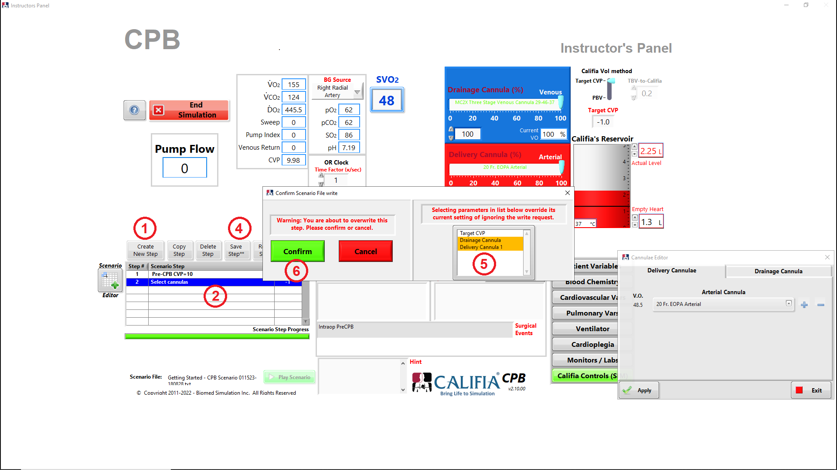

Figure 4.27. Step 2 edits

Scenario File Step 3: Go on pump -
Follow these steps, refer to Figure 4.28
① Press Create New Step
② Type Let’s go on pump for Scenario Step then press <Enter> on keyboard or click away with the mouse
③ Add following note in Skills field: Set gas blender and go on pump
④ Add following in Surgical Events: Go on pump
This is displayed along the top of the Learner Screen
5 Follow steps in Section 4.9 to set gas blender and Section 4.10 to go on pump
⑥ Press Save Step** button
** refers to the step having been modified and needs to be saved
⑦ In the Confirm Scenario File write dialog, select both Skills and Surgical Events
Hold <Ctrl> key to select multiple entries
⑧ Press Confirm button to save step changes to scenario file
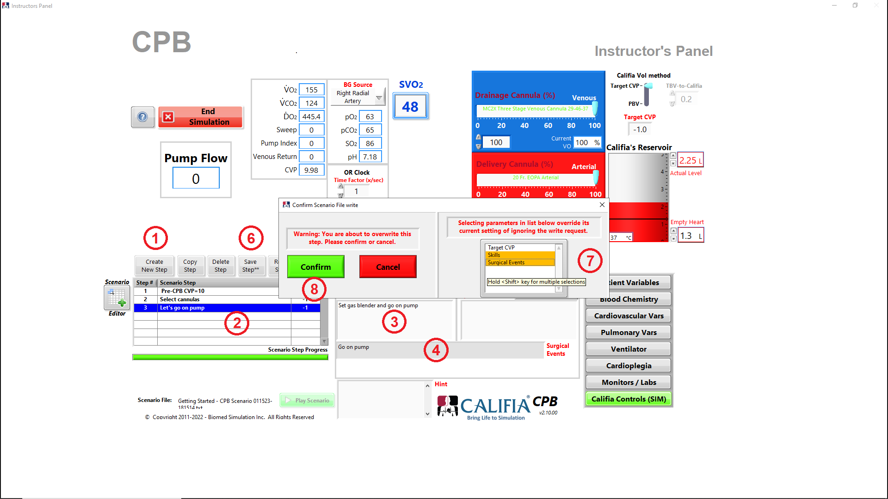

Figure 4.28 Step 3 edits

Scenario File Step 4: Give Cardioplegia -
Follow these steps, refer to Figure 4.29
① Press Create New Step
② Type Give Cardioplegia for Scenario Step then press <Enter> on keyboard or click away with the mouse
③ Remove existing note in Skills field
④ Add following in Surgical Events: Give Cardioplegia
This is displayed along the top of the Learner Screen
5 Follow steps in Section 4.11 to deliver cardioplegia
⑥ Press Save Step** button
** refers to the step having been modified and needs to be saved
⑦ In the Confirm Scenario File write dialog, select both Cross Clamp and CP Delivery
Hold <Ctrl> key to select multiple entries
⑧ Press Confirm button to save step changes to scenario file
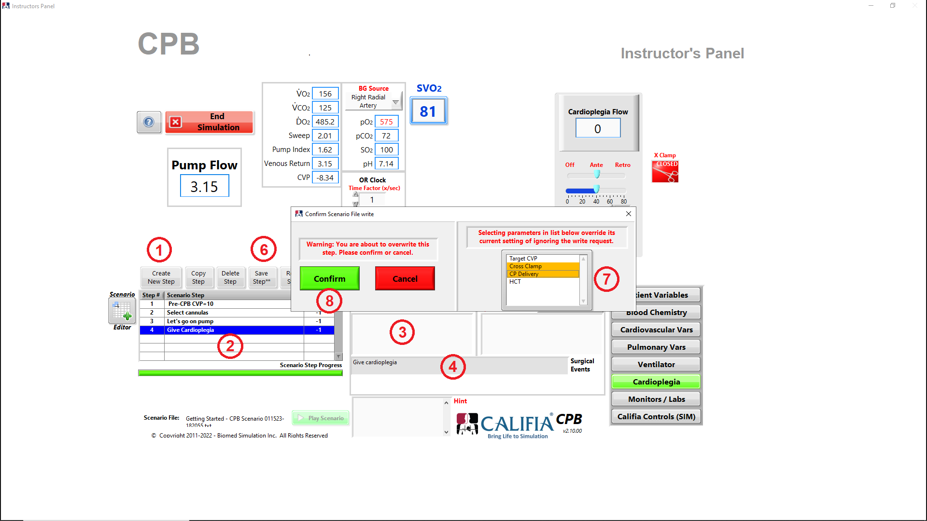

Figure 4.29 Step 4 edits

Scenario File Step 5: Event: Cannula malposition -
Follow these steps, refer to Figure 4.30
① Press Create New Step
② Type Event – Cannula malposition for Scenario Step then press <Enter> on keyboard or click away with the mouse
③ Remove existing note in Surgical Events field
4 Follow steps in Section 4.12 for Event: Cannula malposition
⑤ Press Save Step** button
** refers to the step having been modified and needs to be saved
⑥ In the Confirm Scenario File write dialog, select both Delivery Cannula 1 (%) and Surgical Events
Hold <Ctrl> key to select multiple entries
⑦ Press Confirm button to save step changes to scenario file
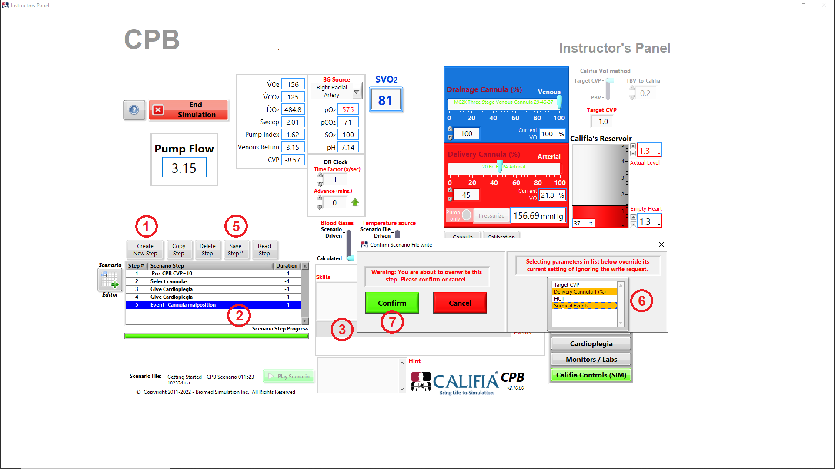
Figure 4.30 Step 5 edits

Scenario File Step 6: Open Cross Clamp
Follow these steps, refer to Figure 4.31
① Press Create New Step
② Type Open Cross Clamp for Scenario Step then press <Enter> on keyboard or click away with the mouse
③ Add following note in Skills field: Return Delivery Cannula to 100% and open cross clamp
4 Follow steps in Section 4.13 to Open Cross Clamp
Also, set Delivery Cannula (%) to 100% since cannula malposition event has been fixed
⑤ Press Save Step** button
** refers to the step having been modified and needs to be saved
⑥ In the Confirm Scenario File write dialog, select Cross Clamp, Delivery Cannula 1 (%) and Skills
Hold <Ctrl> key to select multiple entries
⑦ Press Confirm button to save step changes to scenario file
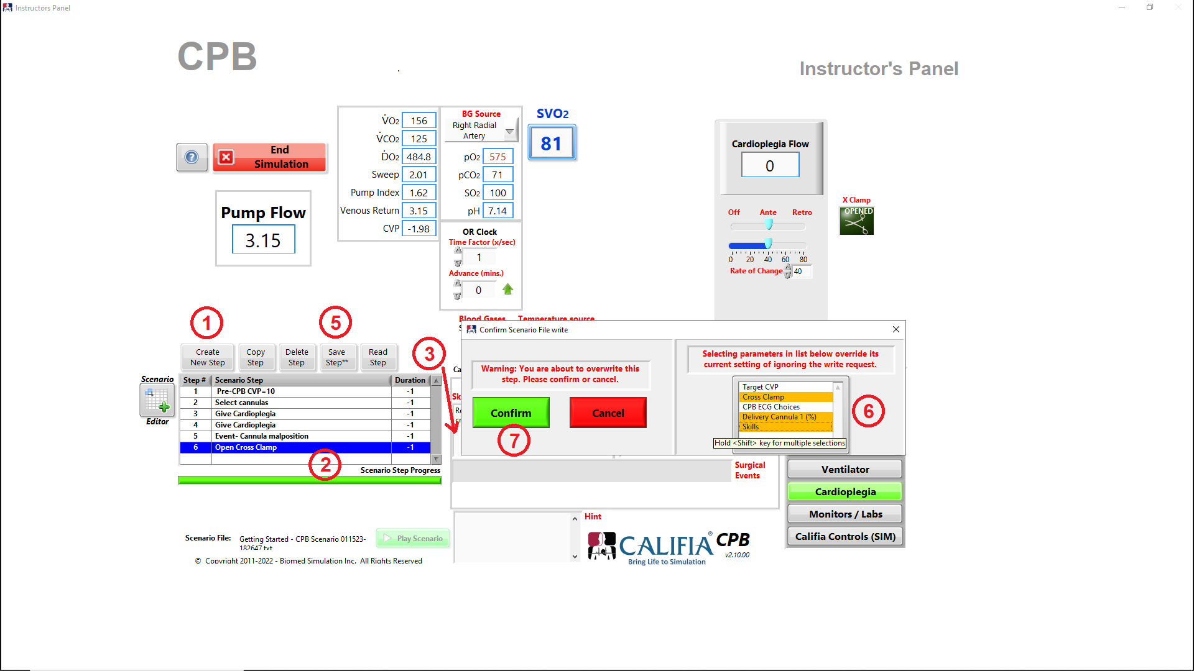

Figure 4.31. Step 6 edits

Scenario File Step 7: Come off pump -
Follow these steps, refer to Figure 4.32
① Press Create New Step
② Type Come off pump for Scenario Step then press <Enter> on keyboard or click away with the mouse
③ Remove existing note in Skills field
4 Follow steps in Section 4.14 to come off pump
⑤ Press Save Step** button
** refers to the step having been modified and needs to be saved
⑥ In the Confirm Scenario File write dialog, select Skills
Hold <Ctrl> key to select multiple entries
⑦ Press Confirm button to save step changes to scenario file
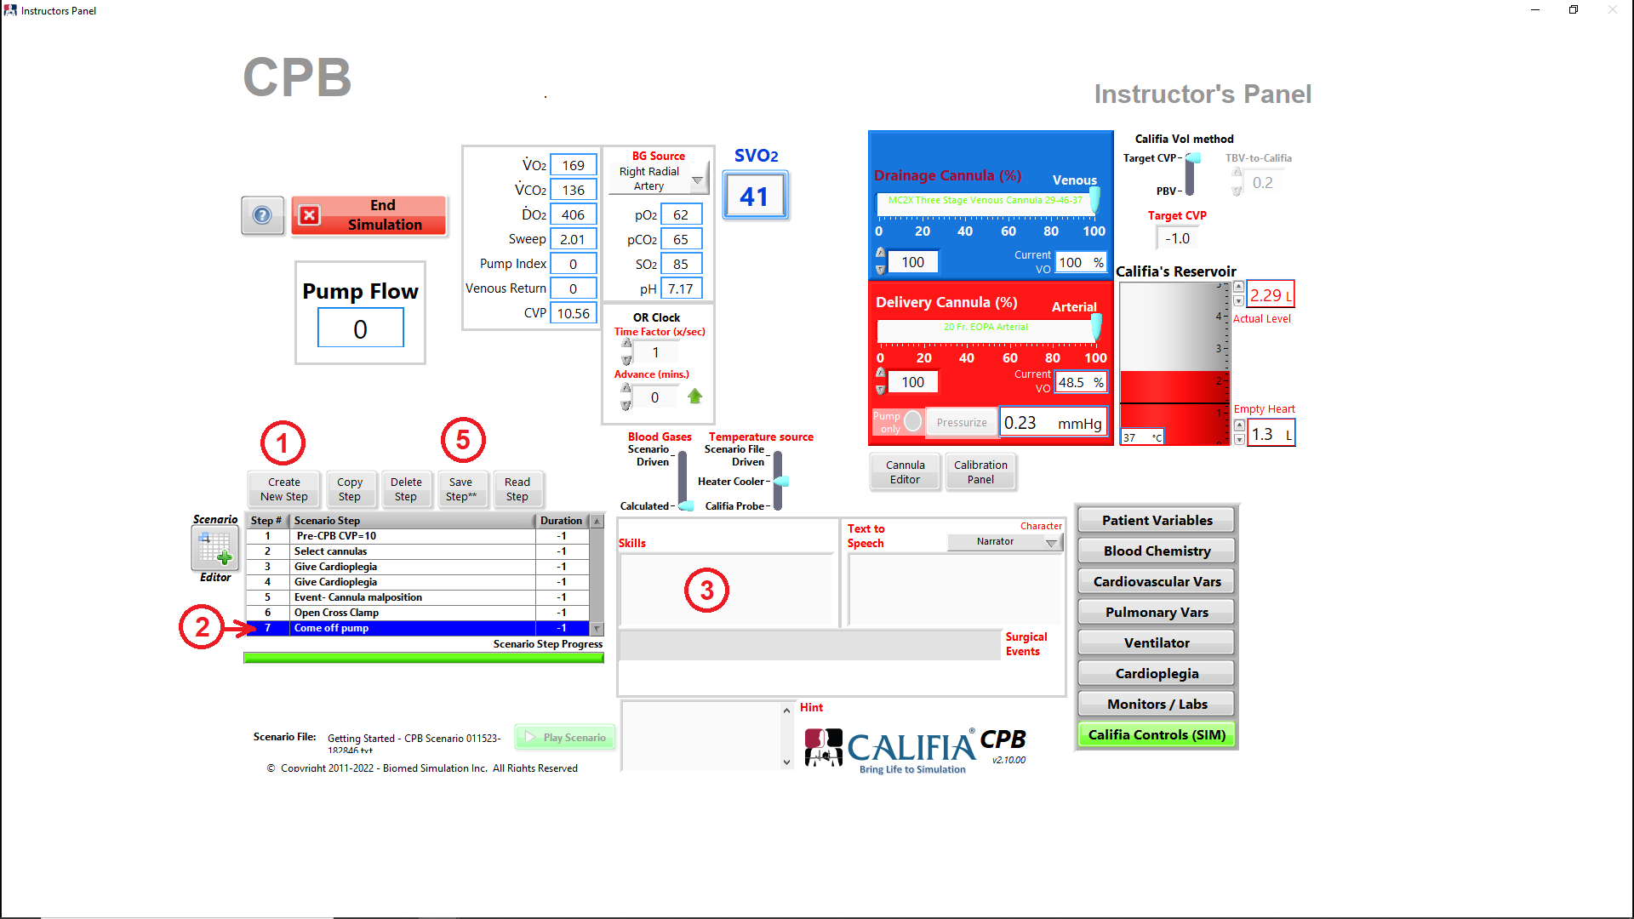
Figure 4.32 Step 7 edits

5

Let’s go on ECMO! – an ECMO simulation
This chapter steps through an ECMO simulation. You can follow along.
Approximately 60 minutes to complete this chapter.

SIM vs Califia Patient Module

Refer to Figure 5.1 , ①.
Sections in this chapter headlined with this image refer to software-only simulation. No CPM or real pump is involved.
Sections in this chapter headlined with this image use an ECMO system connected to the CPM.

Use a Standardized Patient scenario

Select one of the six SP ECMO scenarios available, Figure 5.1, ②:
- SP VA ECMO Adult
- SP VA ECMO Infant
- SP VA ECMO Pediatric
- SP VV ECMO Adult
- SP VV ECMO Infant
- SP VV ECMO Pediatric
Press Continue button, ③, to step into the simulation.
Figure 5.1. Opening Screen "ECMO mode

Patient Demographics

Refer to Figure 5.2, review and change the following:
① Age
② HCT
③ Gender
④ Weight
⑤ Height

Figure 5.2. Patient demographics in Instructor's Panel

CVP Gain

In Instructor’s Panel, press the Calibration Panel button under Califia Controls to bring up the Califia Calibration Panel, Figure5.3. Set CVP Gain as dictated in Table 5.1
BSA (m²) | CVP Gain
< 1 | 3.5
Between 1 & 2 | 3.0
> 2 | 2.5

Table 5.1. BSA vs CVP Gain

Figure 5.3. Califia Calibration Panel > CVP Gain

CVP

Set CVP to 10 mmHg
Fill Califia’s Reservoir until CVP is 10 mmHg, ① in Figure 5.4

Figure 5.4. Fill CPM with water to match target CVP

Refer to Figure 5.5, go to Instructor’s Panel » Califia Controls
① Enter 10 for Target CVP then press <Enter>
② Volume in the virtual Califia’s Reservoir changes until CVP reaches 10, ③.

Figure 5.5. Set Target CVP in SIM mode

Arterial Pressure

Refer to Figure 5.6, in Instructor’s Panel » Cardiovascular Vars,
① Press Set Arterial Pressure button.
② Specify desired Systolic and Diastolic Arterial Pressures.
③ Press Target button.
④ It takes a few seconds to find values for LV Contractility and SVR.
⑤ Press Save Step to save all changes to scenario file.
Close Model Settings panel once targetting is complete.

Figure 5.6. Set Systolic and Diastolic Arterial Pressure

Ventilator Settings

While referring to Figure 5.7 , select Ventilator button in Instructor’s Panel and set values for:
① Rate
② FiO₂
③ PIP
④ PEEP
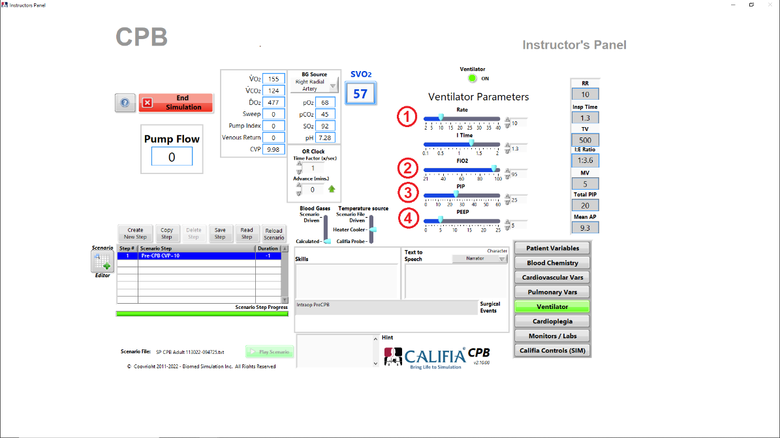

Figure 5.7. Ventilator settings

Blood Gases

Refer to Figure 5.8, go to Instructor’s Panel » Blood Chemistry.
① Press Calculate Desired Gases button
② Specify desired pO2, pCO2 and pH for arterial blood
③ Press Target button
④ It takes several minutes to find values for HCO3, Dead Space and Pulmonary Shunt Fraction, the last two parameters are in the Pulmonary Vars section.
⑤ Press Save Step to save all changes to scenario file.
Close Model Settings panel once targetting is complete.

Figure ‎5.8. Set Blood Gases

Select Delivery and Drainage Cannulas

Refer to Figure 5.9 to select Delivery (arterial) and Drainage (venous) Cannulas. In Instructor’s Panel » Califia Controls,
① Press Cannula Editor button.
②a In Cannula Editor, select a Delivery Cannula from drop-down list then press Apply button.
③a Cannula label and corresponding valve opening is shown.
②b Change to Drainage Cannula, select cannula from drop-down list then press Apply button.
③b Cannula label and corresponding valve opening is shown.
Exit Cannula Editor
Pressure-Flow profiles for cannulas are modeled using respective electromechanical valves in CPM. The same performance profiles are also used in SIM mode.

Figure 5.9 . Cannula selection

Set Gas Blender

Refer to Figure 5.10, gas blender is set in the learner screen.
① Bring up bottom ribbon and select Oxygenator Controls button
② Set Gas Sweep Rate
③ Set Oxygenator FiO₂ by pressing green button then turning blue knob

Figure 5.10. Set Gas Blender

Let’s go on pump!

Remove clamp on venous drainage line to drain patient while flowing using systemic pump.
Notice Arterial Pressure and CVP values decreasing as patient transitions support from native heart to heart lung machine, Figure 5.11.

Figure 5.11. Arterial and CVP decreasing

Prime virtual circuit, refer to Figure 5.12
Bring up bottom ribbon
① Press Fluids Panel button
② Press HLM Controls button
In Fluids Panel
③a Select Crystalloid from Fluids drop-down menu
③b Enter 1000 mL of Volume
③c Light up the Priming button
③d Press Apply button
④ Notice Venous Reservoir fills up with this priming volume

Figure 5.12. Prime circuit using Fluids Panel

To go on bypass, refer to Figure 5.13
② Start increasing systemic pump flow
Virtual systemic pump is a roller pump
③ Watch for arterial pressure waveform flattening though as flow is increased, mean pressure rises

Figure 5.13. Starting bypass (SIM)

Give Cardioplegia
Refer to Figure 5.14 , in Instructor’s Panel » Cardioplegia,
① Set slider to Ante (Antegrade Cardioplegia delivery)
② Close X Clamp

Figure 5.14. Prepare for Cardioplegia delivery

Flow into Cardioplegia port. As flow is registered in the simulation software, the heart ECG will step through various patterns until the heart is completely arrested, Figure 5.15

Figure 5.15 Heart ECG under Cardioplegia delivery

Refer to Figure 5.16
① Close X Clamp in HLM Controls panel
② Increase Cardioplegia pump flow
③ Notice ECG pattern change

Figure 5.16. Heart ECG under Cardioplegia delivery (SIM)

Event: Cannula malposition
Refer to Figure 5.17, in Instructor’s Panel » Califia Controls,
① Set Delivery Cannula (%) slider to about 25%
② Arterial line pressure increases

Figure 5.17. Arterial Cannula set to 25% opened

Arterial line pressure should report a high value due to high resistance generated by the smaller arterial valve opening, Figure 5.18
[JN] – need line manometer photo

Figure 5.18. Line pressure increase (line manometer photo)

Due to the high resistance generated by the smaller arterial valve opening, the arterial line pressure displayed using the pressure panel is very high,Figure 5.19
Line pressure (post-Oxygenator): 168 mmHg
Pre-Oxygenator pressure: 178 mmHg

Figure 5.19. High arterial line pressures (SIM)

Set Delivery Cannula (%) back to 100% once the event is resolved.

Remove Cross Clamp

Refer to Figure 5.20
① Open Cross Clamp in Instructor’s Panel » Cardioplegia
② Notice ECG pattern return to activity, ending in SR.

Figure 5.20. Open Cross Clamp

Refer to Figure 5.21
① Open Cross Clamp in HLM Controls panel
② Notice ECG pattern return to activity, ending in SR.

Figure 5.21. Open Cross Clamp (SIM)

Come off pump!

Refer to Figure 5.22
Start weaning by partially occluding venous drain and filling patient.
① Notice patient’s heart starts to eject and venous pressure increases
Come-off systemic pump as patient’s arterial pressure returns to normal and CVP meets target value.
② Heart has taken over full body perfusion and CVP is normal value

Figure 5.22. Wean off pump

Refer to Figure 5.23
① Start weaning by partially occluding venous drain and filling patient.
② Notice patient’s heart starts to eject and venous pressure increases
③ Come-off systemic pump as patient’s arterial pressure returns to normal and CVP meets target value.
④ Heart has taken over full body perfusion and CVP is normal value

Figure 5.23. Wean off pump (SIM)

Return to Opening Screen
Refer to Figure 5.24, press End Simulation button, confirm request to return to Opening Screen.

Figure 5.24. End Simulation

Create a CPB Simulation Scenario File
In this section, we will repeat the CPB case presented in this chapter however we will save all stages into a scenario file.

5.18 Access Scenario Editor
Refer to Figure 5.25, Press MENU button, ①, followed by Scenario Editor button, ②.

Figure 5.25. Access MENU in Opening Screen then Scenario Editor

5.19 Save Scenario File
Refer to Figure 5.26, in Scenario Editor,
① Press File menu selection
② Select Save As….
③ Enter a new scenario file name such as Getting Started – CPB Scenario
This name is used to create a folder which will host the scenario file and ventilator.ini file
[Optional] – the Button Selector defaults to Other however a different button can be programmed to be associated with the new scenario file
④ Press the Create button to complete the new scenario file creation
Notice the Scenario Editor title reflects the new folder location and file name
⑤ Once new scenario file and folder created, return to File menu and press Close
Press Close button to close the MENU bar, this step is not shown.

Figure 5.26. Save As... in Scenario Editor

5.20 New scenario file in Opening Screen
Refer to Figure 5.27, Opening Screen
① Location of Scenario File points to the newly created Scenario File
② The selected button is Other as specified in the Save As… dialog
③ Press Continue button to load new scenario file

Figure 5.27. Opening Screen - New Scenario File

5.21 Scenario File Step 2: Select cannulas
The original scenario file was saved with patient’s blood gases configured as desired, section X.X. [Blood Gases in p. 25]
Next is to select cannulas. Follow these steps in Instructor’s Panel, refer to Figure 5.28
① Press Create New Step
② Step #2 is added to scenario table; type Select cannulas for Scenario Step then press <Enter> on keyboard or click away with the mouse
3 Follow steps in Section X.X to select cannulas
④ Press Save Step** button
** refers to the step having been modified and needs to be saved
⑤ In the Confirm Scenario File write dialog, select both Drainage Cannula and Delivery Cannula 1
Hold <Ctrl> key to select multiple entries
⑥ Press Confirm button to save step changes to scenario file

Figure 5.28. Step 2 edits

5.22 Scenario File Step 3: Go on pump
Follow these steps, refer to Figure 5.29
① Press Create New Step
② Type Let’s go on pump for Scenario Step then press <Enter> on keyboard or click away with the mouse
③ Add following note in Skills field: Set gas blender and go on pump
④ Add following in Surgical Events: Go on pump
This is displayed along the top of the Learner Screen
5 Follow steps in Section X.X to set gas blender and Section X.X go on pump
⑥ Press Save Step** button
** refers to the step having been modified and needs to be saved
⑦ In the Confirm Scenario File write dialog, select both Skills and Surgical Events
Hold <Ctrl> key to select multiple entries
⑧ Press Confirm button to save step changes to scenario file

Figure 5.29. Step 3 edits

5.23 Scenario File Step 4: Give Cardioplegia
Follow these steps, refer to Figure 5.30
① Press Create New Step
② Type Give Cardioplegia for Scenario Step then press <Enter> on keyboard or click away with the mouse
③ Add following note in Skills field: Set gas blender and go on pump
④ Add following in Surgical Events: Give Cardioplegia
This is displayed along the top of the Learner Screen
5 Follow steps in Section X.X to deliver cardioplegia
⑥ Press Save Step** button
** refers to the step having been modified and needs to be saved
⑦ In the Confirm Scenario File write dialog, select both Skills and Surgical Events
Hold <Ctrl> key to select multiple entries
⑧ Press Confirm button to save step changes to scenario file

Figure 5.30. Step 4 edits

5.24 Scenario File Step 5: Event: Cannula malposition
Follow these steps, refer to Figure 5.31
① Press Create New Step
② Type Event – Cannula malposition for Scenario Step then press <Enter> on keyboard or click away with the mouse
③ Remove existing note in Surgical Events field
4 Follow steps in Section X.X for Event: Cannula malposition
⑤ Press Save Step** button
** refers to the step having been modified and needs to be saved
⑥ In the Confirm Scenario File write dialog, select both Delivery Cannula 1 (%) and Surgical Events
Hold <Ctrl> key to select multiple entries
⑦ Press Confirm button to save step changes to scenario file

Figure 5.31. Step 5 edits

5.25 Scenario File Step 6: Open Cross Clamp
Follow these steps, refer to Figure 5.32
① Press Create New Step
② Type Open Cross Clamp for Scenario Step then press <Enter> on keyboard or click away with the mouse
③ Add following note in Skills field: Return Delivery Cannula to 100% and open cross clamp
4 Follow steps in Section X.X to Open Cross Clamp
Also, set Delivery Cannula (%) to 100% since cannula malposition event has been fixed
⑤ Press Save Step** button
** refers to the step having been modified and needs to be saved
⑥ In the Confirm Scenario File write dialog, select Cross Clamp, Delivery Cannula 1 (%) and Skills
Hold <Ctrl> key to select multiple entries
⑦ Press Confirm button to save step changes to scenario file

Figure 5.32. Step 6 edits

5.26 Scenario File Step 7: Come off pump
Follow these steps, refer to Figure 5.33
① Press Create New Step
② Type Come off pump for Scenario Step then press <Enter> on keyboard or click away with the mouse
③ Remove existing note in Skills field
4 Follow steps in Section X.X to come off pump
⑤ Press Save Step** button
** refers to the step having been modified and needs to be saved
⑥ In the Confirm Scenario File write dialog, select Skills
Hold <Ctrl> key to select multiple entries
⑦ Press Confirm button to save step changes to scenario file

Figure 5.33. Step 7 edits

Working on icons for document in process.
Icon | Description | Icon | Image
 | Help / Note | 
 | Warning | 
 | Warning / Alert | 
 | Time / Duration | 

